|  |  |
| --- | --- |
| Logo_FPT_University_doc | **MINISTRY OF EDUCATION AND TRAINING** |

**FPT UNIVERSITY**

**CAPSTONE PROJECT DOCUMENT**

**AGC101**

**Report #4 – Software Design Description**

|  |  |
| --- | --- |
| **Tra Da** | |
| **Group Member** | SE03451 – Soulivong Phimmathong |
| SE03271 – Hoang Van Canh |
| SE03030 – Vu Hoang Hieu |
| SE03193 – Nguyen Hoang |
| SE03334 – Nguyen Huu Thao |
| **Supervisor** | Mr Nguyen Van Sang |
| **Project Code** | AGC101 |

Hanoi, May 2016 – August 2016

Table of Contents

[1 ARCHITECTURE DESIGN 5](#_Toc459650779)

[1.1 Choice of Architecture Design 5](#_Toc459650780)

[1.1.1 Introduction to CodeIgniter 5](#_Toc459650781)

[1.1.2 Model-View-Controller in CodeIgniter 5](#_Toc459650782)

[1.2 Architectural Presentation 7](#_Toc459650783)

[1.3 Package Design 8](#_Toc459650784)

[2 DETAILED DESIGN 9](#_Toc459650785)

[2.1 Class Description 9](#_Toc459650786)

[2.1.1 Admin 9](#_Toc459650787)

[2.1.2 Home 12](#_Toc459650788)

[2.1.3 Restaurant 13](#_Toc459650789)

[2.1.4 User\_profile 14](#_Toc459650790)

[2.1.5 Ckfinder 17](#_Toc459650791)

[2.2 UC001: Admin Management 19](#_Toc459650792)

[2.2.1 Class diagram 19](#_Toc459650793)

[2.2.2 UC001 – 01 Write news 20](#_Toc459650794)

[2.2.3 UC001 – 02 Create category 22](#_Toc459650795)

[2.2.4 UC001 – 03 Update news 24](#_Toc459650796)

[2.2.5 UC001 – 04 Update category 26](#_Toc459650797)

[2.2.6 UC001 – 05 Delete category 27](#_Toc459650798)

[2.2.7 UC001 – 06 Delete news 29](#_Toc459650799)

[2.2.8 UC001 – 07, 09 Activate/deactivate and rate restaurant 30](#_Toc459650800)

[2.2.9 UC001 – 08 Delete restaurant 33](#_Toc459650801)

[2.2.10 UC001 – 10 Delete user 35](#_Toc459650802)

[2.2.11 UC001 – 11 Activate/deactivate user 36](#_Toc459650803)

[2.2.12 UC001 – 12 View all news 39](#_Toc459650804)

[2.2.13 UC001 – 13 View all categories 40](#_Toc459650805)

[2.2.14 UC001 – 14 View all restaurants 42](#_Toc459650806)

[2.2.15 UC001 – 15 View all users 43](#_Toc459650807)

[2.2.16 UC001 – 16 View all booking 45](#_Toc459650808)

[2.2.17 UC001 – 17 View detail booking 46](#_Toc459650809)

[2.2.18 UC001 – 18 Report statistics 48](#_Toc459650810)

[2.3 UC002 Customer Management 50](#_Toc459650811)

[2.3.1 Class Diagram 50](#_Toc459650812)

[2.3.2 UC002 – 01 Login 51](#_Toc459650813)

[2.3.3 UC002 – 02 Log out 53](#_Toc459650814)

[2.3.4 UC002 – 03 View account 54](#_Toc459650815)

[2.3.5 UC002 – 04 Update account 57](#_Toc459650816)

[2.3.6 UC002 – 05 Update password 59](#_Toc459650817)

[2.3.7 UC002 – 06 Book restaurant 61](#_Toc459650818)

[2.3.8 UC002 – 07 Upload avatar 62](#_Toc459650819)

[2.3.9 UC002 – 08 View booking history 65](#_Toc459650820)

[2.4 UC003 Restaurant Owner Management 67](#_Toc459650821)

[2.4.1 Class Diagram 67](#_Toc459650822)

[2.4.2 UC003 – 01 Add restaurant information 68](#_Toc459650823)

[2.4.3 UC003 – 02 Update restaurant info 73](#_Toc459650824)

[2.4.4 UC003 – 03 Add restaurant banner 76](#_Toc459650825)

[2.4.5 UC003 – 04 Delete restaurant banner 78](#_Toc459650826)

[2.4.6 UC003 – 05 Add food 79](#_Toc459650827)

[2.4.7 UC003 – 06 Update food information 82](#_Toc459650828)

[2.4.8 UC003 – 07 Update booking status 84](#_Toc459650829)

[2.4.9 UC002 – 08 View booking history 86](#_Toc459650830)

[2.5 UC004 Guest 88](#_Toc459650831)

[2.5.1 Class Diagram 88](#_Toc459650832)

[2.5.2 UC004 – 01 Register 89](#_Toc459650833)

[2.5.3 UC004 – 02 View news by category 91](#_Toc459650834)

[2.5.4 UC004 – 03 View news detail 93](#_Toc459650835)

[2.5.5 UC004 – 04 Filter restaurant by category 94](#_Toc459650836)

[2.5.6 UC004 – 05 View restaurant detail 96](#_Toc459650837)

[2.5.7 UC004 – 06 Like/Unlike 98](#_Toc459650838)

[2.5.8 UC004 – 07 Comment 99](#_Toc459650839)

[2.5.9 UC004 – 08 Share 101](#_Toc459650840)

[3 DATABASE DESIGN 103](#_Toc459650841)

[3.1 Database Diagram 103](#_Toc459650842)

[3.2 Table Descriptions 104](#_Toc459650843)

[3.2.1 Table address 104](#_Toc459650844)

[3.2.2 Table booking 104](#_Toc459650845)

[3.2.3 Table categoriesofrestaurant 105](#_Toc459650846)

[3.2.4 Table district 106](#_Toc459650847)

[3.2.5 Table food 106](#_Toc459650848)

[3.2.6 Table images 107](#_Toc459650849)

[3.2.7 Table memberships 107](#_Toc459650850)

[3.2.8 Table news 108](#_Toc459650851)

[3.2.9 Table province 109](#_Toc459650852)

[3.2.10 Table restaurantcategories 109](#_Toc459650853)

[3.2.11 Table restaurantImage 110](#_Toc459650854)

[3.2.12 Table restaurants 110](#_Toc459650855)

[3.2.13 Table users 112](#_Toc459650856)

[3.2.14 Table ward 113](#_Toc459650857)

[4 References 113](#_Toc459650858)

# ARCHITECTURE DESIGN

## Choice of Architecture Design

In this project we follow Model View Viewmodel (MVVM) architecture and use CodeIgniter framework to implement the system.

### Introduction to CodeIgniter

CodeIgniter is an Application Development Framework - a toolkit - for people who build web sites using PHP. Its goal is to enable you to develop projects much faster than you could if you were writing code from scratch, by providing a rich set of libraries for commonly needed tasks, as well as a simple interface and logical structure to access these libraries. CodeIgniter lets you creatively focus on your project by minimizing the amount of code needed for a given task.

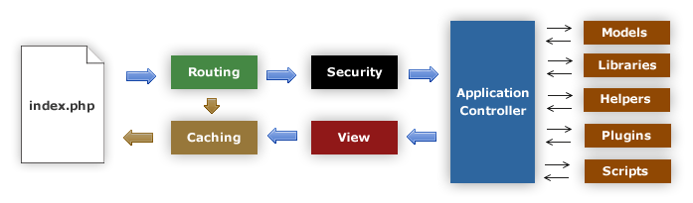

Figure 1: CodeIgniter flow chart

### Model-View-Controller in CodeIgniter

CodeIgniter is based on the Model-View-Controller development pattern. MVC is a software approach that separates application logic from presentation. In practice, it permits your web pages to contain minimal scripting since the presentation is separate from the PHP scripting.

* The Model represents your data structures. Typically your model classes will contain functions that help you retrieve, insert, and update information in your database.
* The View is the information that is being presented to a user. A View will normally be a web page, but in CodeIgniter, a view can also be a page fragment like a header or footer. It can also be an RSS page, or any other type of “page”.
* The Controller serves as an intermediary between the Model, the View, and any other resources needed to process the HTTP request and generate a web page.

CodeIgniter has a fairly loose approach to MVC since Models are not required. If you don’t need the added separation, or find that maintaining models requires more complexity than you want, you can ignore them and build your application minimally using Controllers and Views. CodeIgniter also enables you to incorporate your own existing scripts, or even develop core libraries for the system, enabling you to work in a way that makes the most sense to you.

## Architectural Presentation

Web browser

AGC

Presentation Layer

(CodeIgniter)

View Model

View

Controller

Data model

(CodeIgniter)

Database

(MySql)

Figure 2: AGC101 System overview

## Package Design

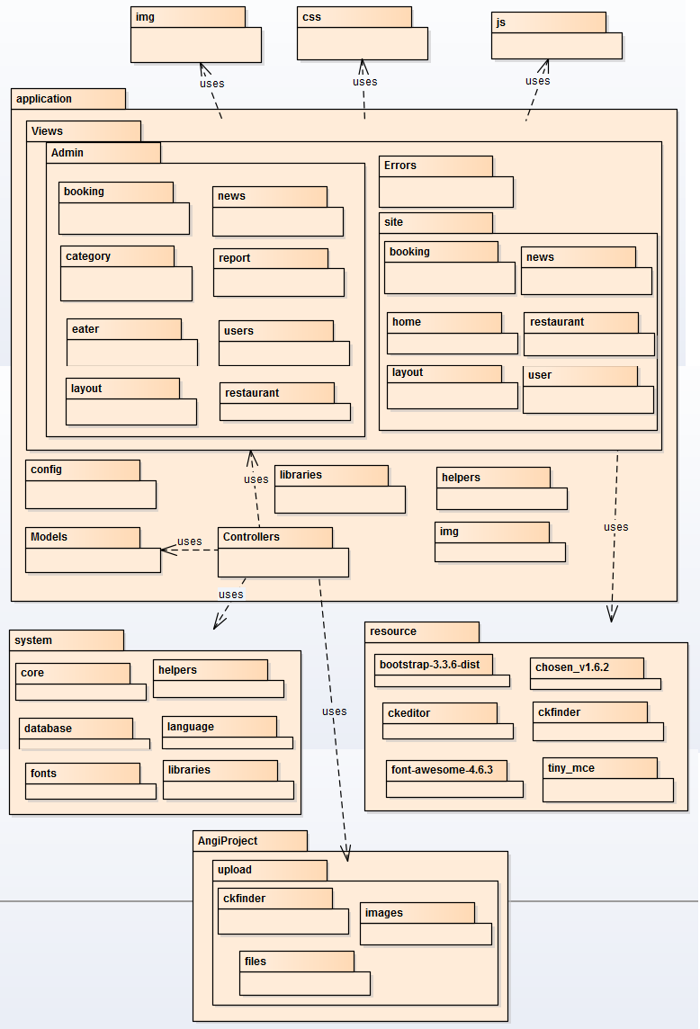

Figure 3: AGC Package Diagram

# DETAILED DESIGN

## Class Description

### Admin

|  |  |  |  |  |
| --- | --- | --- | --- | --- |
| Class | Admin | | | |
| **Description** | Include all functions and display screen of administrator. | | | |
| **Base Class** | CI\_Controller | | | |
| **Constructor** | \_\_construct | | | |
| **Prototype** | N/A | | | |
| **Source File** | Admin.php | | | |
| **Namespace** | N/A | | | |
| **Attributes** | N/A | | | |
| **Methods** | Name | Input | Output | Description |
| index | N/A | Null | Display main screen of administrator. |
| news | offset | Null | Display list news screen. |
| add\_news | N/A | Null | Display screen to add new news and insert into database |
| edit\_news | newsID | Null | Display screen to update a news and update into database |
| delete\_news | newsID | Null | Delete a news in database |
| restaurant | offset | Null | Display list restaurants screen |
| validateRestaurant | data, error | String | Check input data. |
| edit\_restaurant | restaurantID | Null | Display screen to active and rate a restaurant and update into database |
| delete\_restaurant | restaurantID | Null | Delete a restaurant in database |
| info\_food | foodID | Null | Display informations foods of restaurant |
| returnError | msg | String | Return error message |
| returnSuccess | msg | String | Return success message |
| getDistrictByProvinceId | provinceID | Null | Get information of district by province’s id |
| getWardByDistrictId | districtID | Null | Get information of ward by district’s id |
| eater | level, offset | Null | Display list accounts of eaters and restaurants |
| edit\_eater | eaterID | Null | Display screen to active accounts of eaters or restaurants and update into database |
| delete\_eater | eaterID,level | Null | Delete a account in database |
| categories | N/A | Null | Display list categories screen. |
| add\_category | N/A | Null | Display screen to add a category and insert into database |
| edit\_category | categoryID | Null | Display screen to edit a category and update into database |
| booking | offset | Null | Display list booking of restaurants screen. |
| show\_booking | bookingID | Null | Display detail booking screen. |
| report\_statistics | N/A | Null | Display statistics report of website screen. |
| getConfig | N/A | Array | Paging for website |
| setting | N/A | Null | Setting website |
| check\_id | id,uri | Null | Check account’s id |
| Error | value | String | Display error on screen. |

Table 1: Admin class description

### Home

|  |  |  |  |  |
| --- | --- | --- | --- | --- |
| Class | Home | | | |
| **Description** | Include all functions and display screen of the homepage. | | | |
| **Base Class** | CI\_Controller | | | |
| **Constructor** | \_\_construct | | | |
| **Prototype** | N/A | | | |
| **Source File** | Home.php | | | |
| **Namespace** | N/A | | | |
| **Attributes** | N/A | | | |
| **Methods** | Name | Input | Output | Description |
| getConfig | N/A | Array | Paging for website |
| index | N/A | Null | Display home screen of website. |
| search | categoryID, districtID, keyword, offset | Null | Display all restaurants by searched keyword. |
| category | categoryID, offset | Null | Display all restaurants by category |
| home\_view\_all | title, type, offset | Null | Display all restaurants sort by rating or discount. |
| news | categoryID, offset | Null | Display all news in website |
| newsDetails | newsID | Null | Display news detail. |
| login | N/A | Null | Display login dialog. |
| logout | N/A | Null | Logout account. |
| signup | N/A | Null | Dislay signup screen and insert account into database. |
| getDistrictByProvinceId | provinceID | Null | Get information of district by province’s id |
| getWardByDistrictId | districtID | Null | Get information of ward by district’s id |
| returnError | msg | Array | Return error message. |
| returnSuccess | msg | Array | Return success message. |
| GetNameOfTypeNews | categoryID | String | Return type of news. |

Table 2: Home class description

### Restaurant

|  |  |  |  |  |
| --- | --- | --- | --- | --- |
| Class | Restaurant | | | |
| **Description** | Include all functions and display screen of restaurant. | | | |
| **Base Class** | CI\_Controller | | | |
| **Constructor** | \_\_construct | | | |
| **Prototype** | N/A | | | |
| **Source File** | Restaurant.php | | | |
| **Namespace** | N/A | | | |
| **Attributes** | N/A | | | |
| **Methods** | Name | Input | Output | Description |
| view | restaurantID | Null | Display restaurant detail screen |
| sendBooking | N/A | String | Send table booking to restaurant and insert into database. |
| returnError | msg | Array | Return error message. |
| returnSuccess | msg | Array | Return success message. |

Table 3: Restaurant class description

### User\_profile

|  |  |  |  |  |
| --- | --- | --- | --- | --- |
| Class | User\_profile | | | |
| **Description** | Include all functions and display screen of user profile. | | | |
| **Base Class** | CI\_Controller | | | |
| **Constructor** | \_\_construct | | | |
| **Prototype** | N/A | | | |
| **Source File** | User\_profile.php | | | |
| **Namespace** | N/A | | | |
| **Attributes** | N/A | | | |
| **Methods** | Name | Input | Output | Description |
| getConfig | N/A | Array | Paging for website |
| index | N/A | Null | Display profile screen of user. |
| restaurant\_add | N/A | Null | Display information of restaurant for restaurant account to add new information and insert into database. |
| restaurant\_edit | N/A | Null | Display information of restaurant for restaurant account to edit and update information restaurant into database |
| add\_food | N/A | Null | Display screen to add food for restaurant and insert into database. |
| info\_food | foodID | Null | Display food’s information screen. |
| delete\_food | foodID | Null | Delete food in restaurant and delete food in database. |
| edit\_food | foodID | Null | Display food’s information screen, edit and update information of food in database. |
| addoredit\_food | foodID | Null | Check action add or edit food. |
| validateRestaurant | data, error | String | Check input data of restaurant and return warning message. |
| change\_Password | N/A | Null | Display screen to change password and update into database. |
| changeAvatar | N/A | Null | Change avatar for account. |
| Restaurant\_Banner | offset | Null | Display screen to change banner for restaurant account |
| delete\_restaurant\_banner | bannerID | Null | Delete banner of restaurant. |
| add\_restaurant\_banner | N/A | Null | Add banner for restaurant |
| restaurant\_manage\_booking | offset | Null | Display screen to manage booking of customer for restaurant account. |
| user\_manage\_booking | offset | Null | Display history of booking for customer |
| edit\_booking | bookingID | Null | Display screen to edit information of booking and update into database for restaurant account. |
| info\_booking | bookingID | Null | Display booking’s information screen. |
| check\_id | id, uri | Null | Check id is number. |
| Success | value | String | Return success message with html. |
| Error | value | String | Return error message with html. |
| returnError | msg | Array | Return error message without html. |
| returnSuccess | msg | Array | Return error message without html. |

Table 4: User\_profile class description

### Ckfinder

|  |  |  |  |  |
| --- | --- | --- | --- | --- |
| Class | Ckfinder | | | |
| **Description** | Include all commands of ckfinder, which is tool to upload image. | | | |
| **Base Class** | N/A | | | |
| **Constructor** | N/A | | | |
| **Prototype** | N/A | | | |
| **Source File** | Ckfinder.php | | | |
| **Namespace** | N/A | | | |
| **Attributes** | N/A | | | |
| **Methods** | Name | Input | Output | Description |
| setProjectPath | path | Null | Create name of project. |
| setCkfinderSourcePath | path | Null | Create link into folder |
| setAuthentication | status | Null | Check authentication. |
| setConnectorPath | path | Null | Create connection. |
| setFolderUpload | path | Null | Create folder to upload and save image |
| startConnector | N/A | Null | Start connector. |
| getHTML | N/A | Null | Get html code of ckfinder. |

Table 5: Ckfinder class description

## UC001: Admin Management

### Class diagram

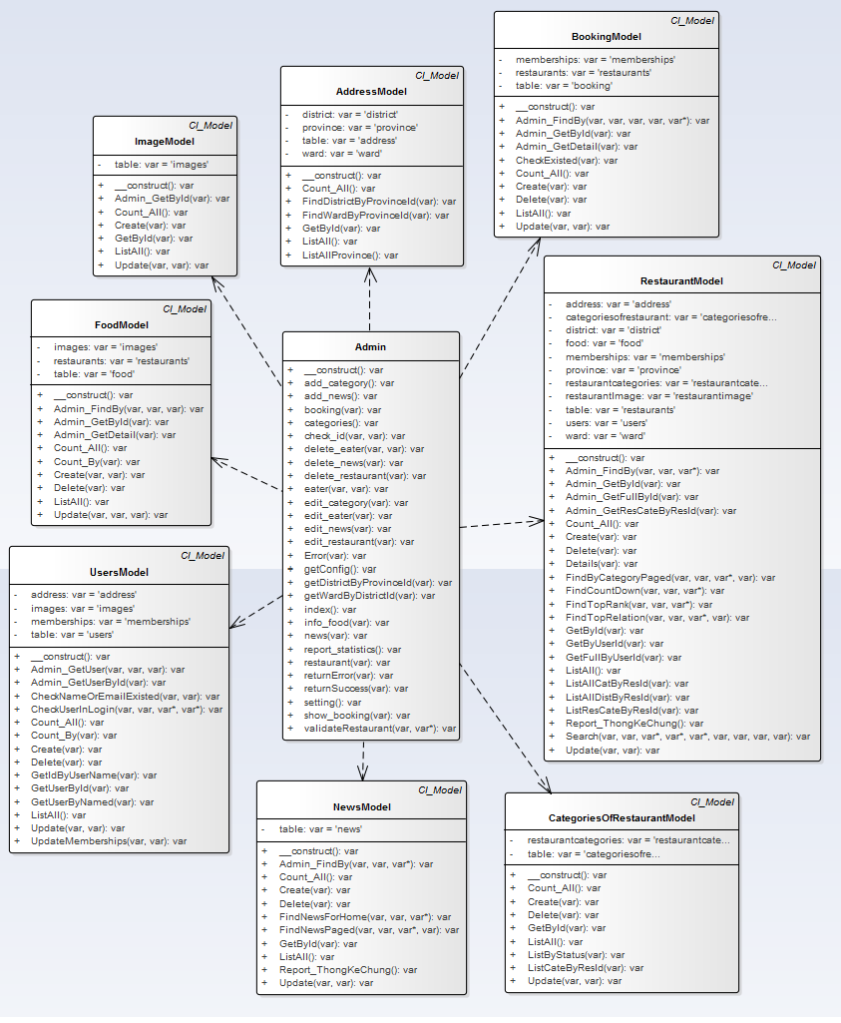

Figure 4: Class diagram

### UC001 – 01 Write news

#### Screen Design

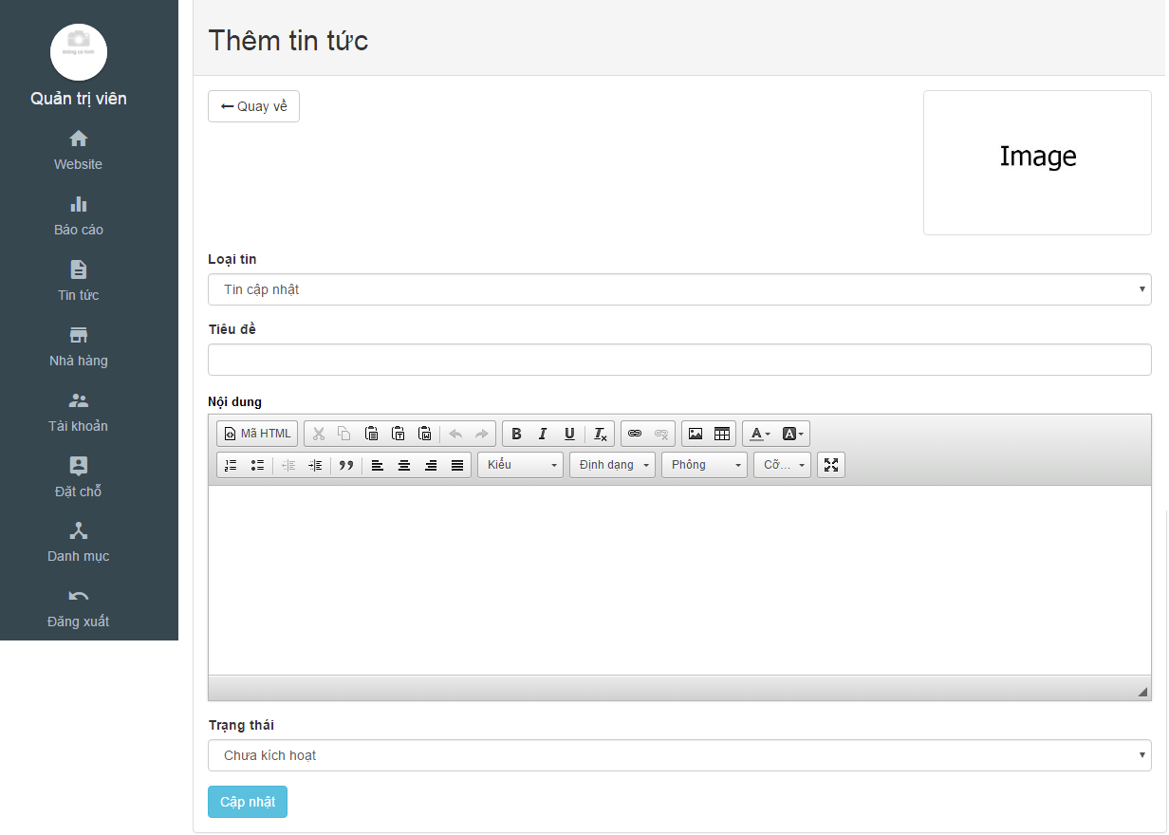

Figure 5: Write news screen design

|  |  |  |  |  |  |  |
| --- | --- | --- | --- | --- | --- | --- |
| **No** | **Object/ Control Name** | **Object/ Control Name in English** | **Type** | **Required** | **Length** | **Description** |
| 1 | Image | Image | Image | Yes | N/A | Image of news |
| 2 | Loại tin | Type of news | Text-box | Yes | N/A | Type of news |
| 3 | Tiêu đề | Title | Text-box | Yes | N/A | Title of news |
| 4 | Nội dung | Content | Text-box | Yes | N/A | Content of news |
| 5 | Trạng thái | Status | Combobox | Yes | N/A | Status of news |
| 6 | Cập nhật | Update | Button | Yes | N/A | Click to add a news |
| 7 | Quay về | Back | Button | Yes | N/A | Return to list news |

Table 6: Write news screen description

#### Sequence Diagram

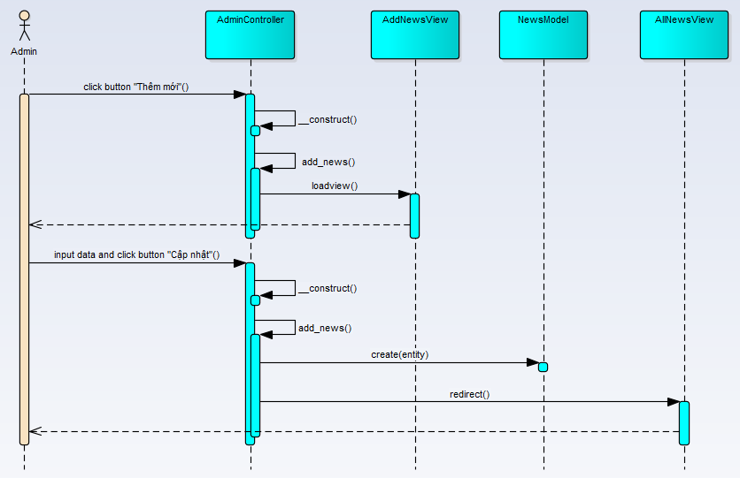

Figure 6: Write news sequence diagram

### UC001 – 02 Create category

#### Screen Design

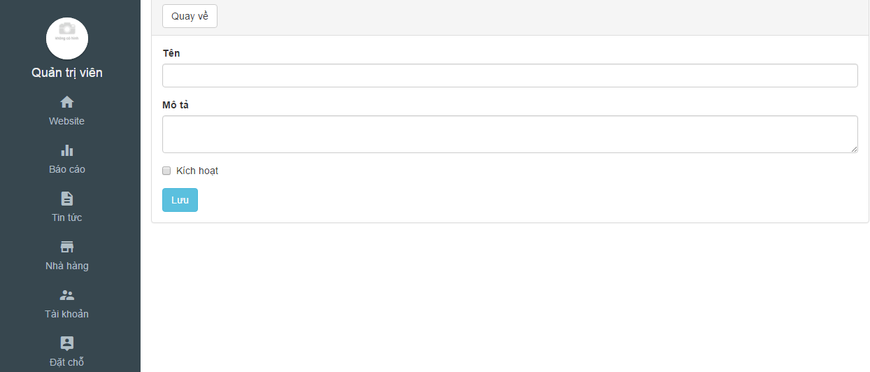

Figure 7: Add new category

|  |  |  |  |  |  |  |
| --- | --- | --- | --- | --- | --- | --- |
| **No** | **Object/ Control Name** | **Object/ Control Name in English** | **Type** | **Required** | **Length** | **Description** |
| 1 | Tên | Name | Text-box | Yes | N/A | Name of category |
| 2 | Mô tả | Description | Text-box | Yes | N/A | Content of category |
| 3 | Kích hoạt | Active | Check-box | Yes | N/A | Status of category |
| 4 | Lưu | Save | Button | Yes | N/A | Click to add a category |
| 5 | Quay về | Back | Button | Yes | N/A | Return to list category |

Table 7: Add new category

#### Sequence Diagram

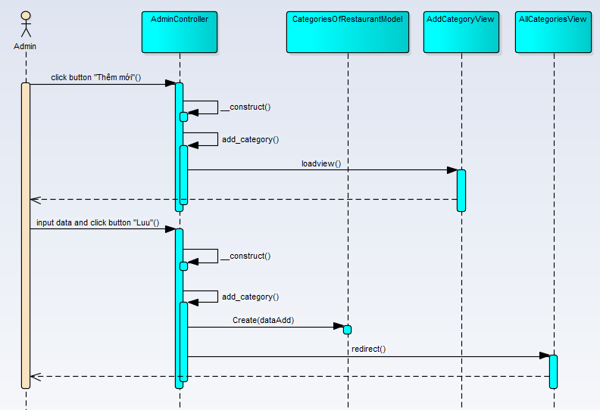

Figure 8: Create category sequence diagram

### UC001 – 03 Update news

#### Screen Design

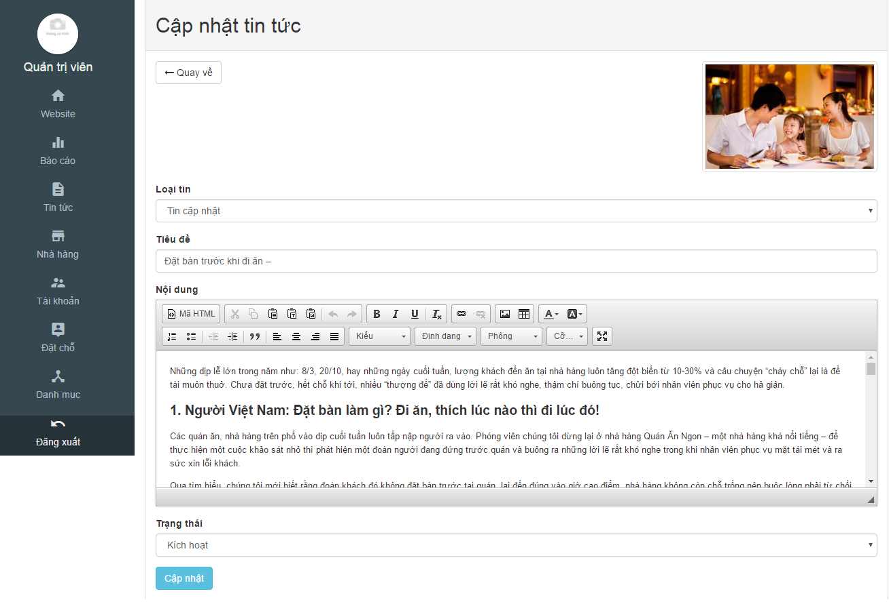

Figure 9: Add news

|  |  |  |  |  |  |  |
| --- | --- | --- | --- | --- | --- | --- |
| **No** | **Object/ Control Name** | **Object/ Control Name in English** | **Type** | **Required** | **Length** | **Description** |
| 1 | Image | Image | Image | Yes | N/A | Image of news |
| 2 | Loại tin | Type of news | Text-box | Yes | N/A | Type of news |
| 3 | Tiêu đề | Title | Text-box | Yes | N/A | Title of news |
| 4 | Nội dung | Content | Text-area | Yes | N/A | Content of news |
| 5 | Trạng thái | Status | Check-box | Yes | N/A | Status of news |
| 6 | Cập nhật | Update | Button | Yes | N/A | Click to update news |
| 7 | Quay về | Back | Button | Yes | N/A | Return to list news |

Table 8: Add news

#### Sequence Diagram

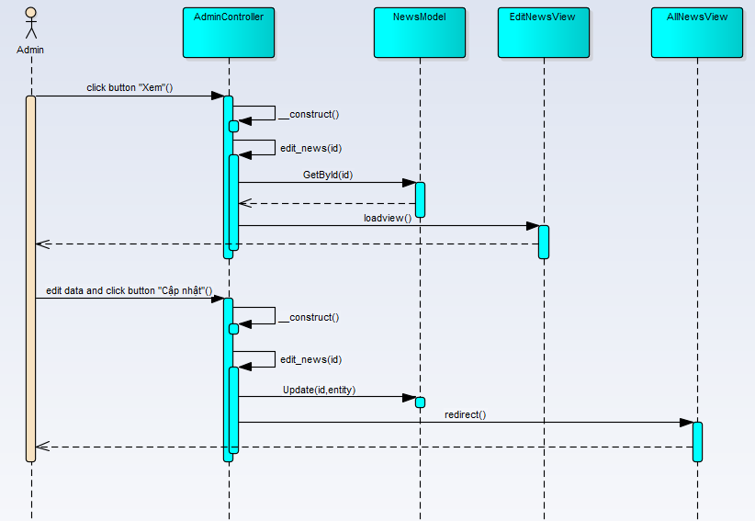

Figure 10: Update news sequence diagram

### UC001 – 04 Update category

#### Screen Design

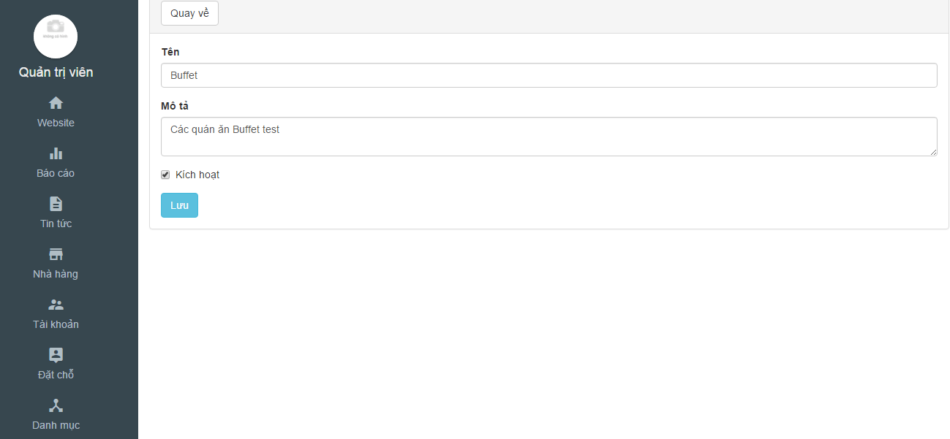

Figure 11: Update category

|  |  |  |  |  |  |  |
| --- | --- | --- | --- | --- | --- | --- |
| **No** | **Object/ Control Name** | **Object/ Control Name in English** | **Type** | **Required** | **Length** | **Description** |
| 1 | Tên | Name | Text-box | Yes | N/A | Name of category |
| 2 | Mô tả | Description | Text-box | Yes | N/A | Content of category |
| 3 | Kích hoạt | Active | Check-box | Yes | N/A | Status of category |
| 4 | Lưu | Save | Button | Yes | N/A | Click to update category |
| 5 | Quay về | Back | Button | Yes | N/A | Return to list category |

Table 9: Update category

#### Sequence Diagram

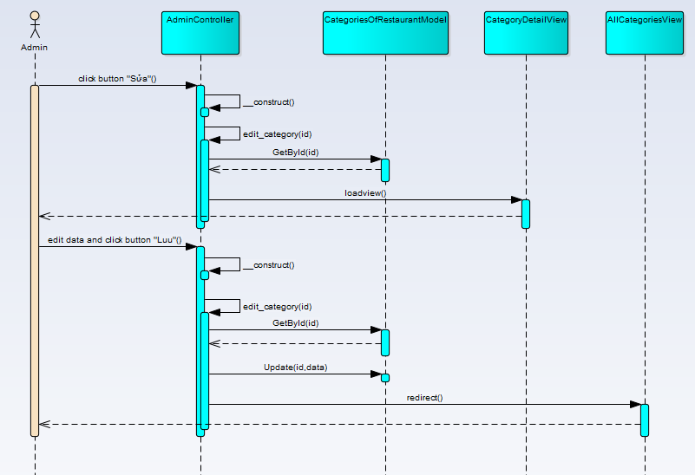

Figure 12: Update category sequence diagram

### UC001 – 05 Delete category

#### Screen Design

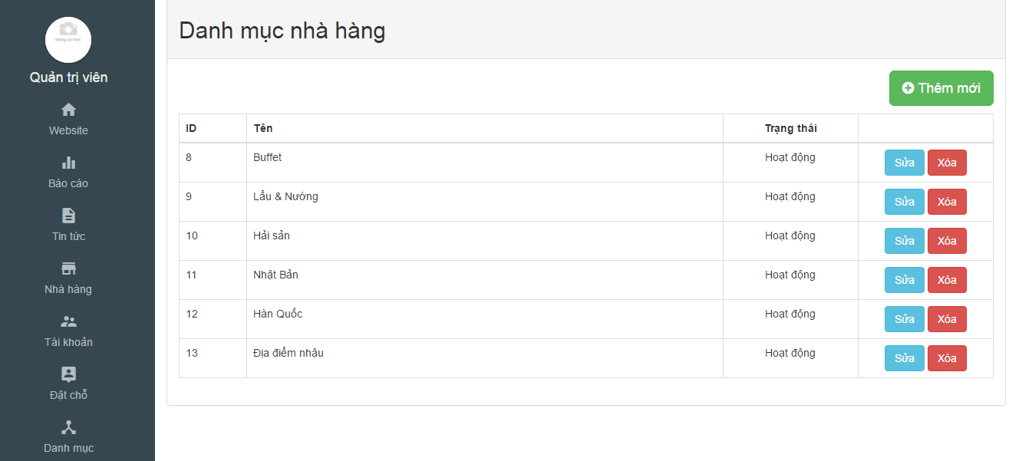

Figure 13: Delete category

|  |  |  |  |  |  |  |
| --- | --- | --- | --- | --- | --- | --- |
| **No** | **Object/ Control Name** | **Object/ Control Name in English** | **Type** | **Required** | **Length** | **Description** |
| 1 | ID | ID | Integer | Yes | N/A | Id of category |
| 2 | Tên | Name | Text | Yes | N/A | Name of category |
| 3 | Trạng thái | Status | Text | Yes | N/A | Status of category |
| 4 | Xóa | Delete | Button | Yes | N/A | Click to delete category |

Table 10: Detele category

#### Sequence Diagram

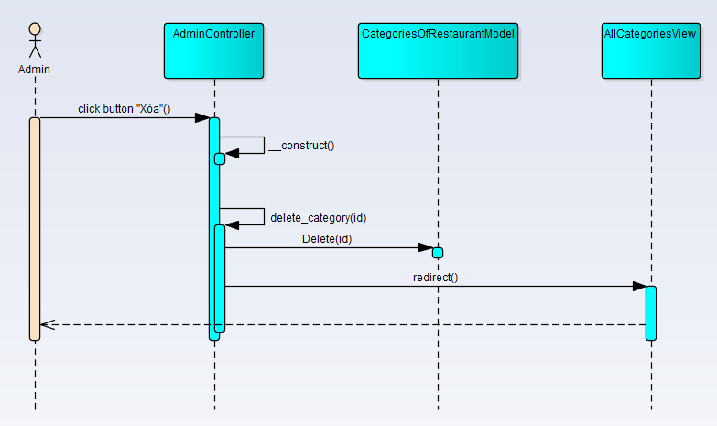

Figure 14: Delete category sequence diagram

### UC001 – 06 Delete news

#### Screen Design

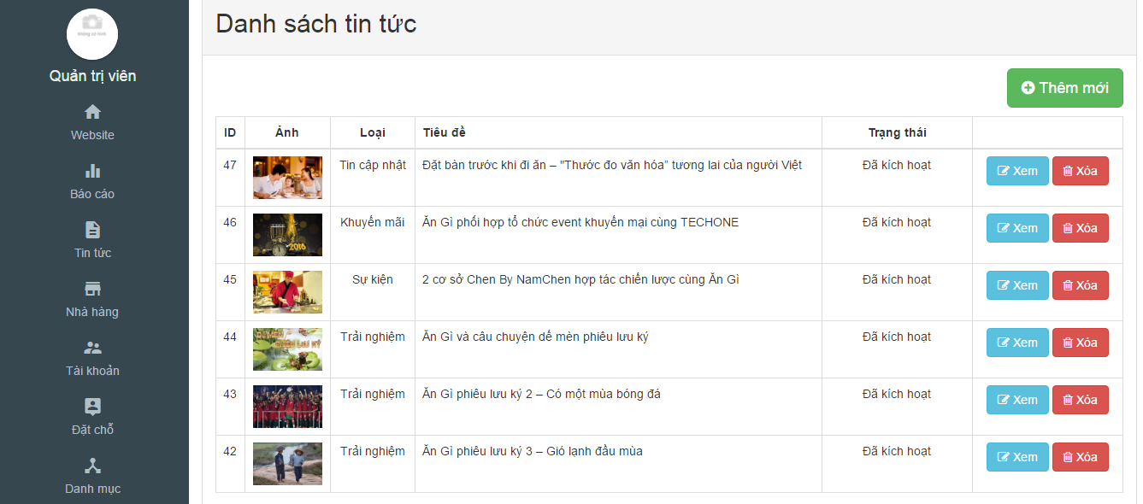

Figure 15: Detele news

|  |  |  |  |  |  |  |
| --- | --- | --- | --- | --- | --- | --- |
| **No** | **Object/ Control Name** | **Object/ Control Name in English** | **Type** | **Required** | **Length** | **Description** |
| 1 | ID | ID | Integer | Yes | N/A | Id of category |
| 2 | Ảnh | Image | Image | Yes | N/A | Image of news |
| 3 | Loại | Category | Text | Yes | N/A | Category of news |
| 4 | Tiêu đề | Title | Text | Yes | N/A | Title of news |
| 5 | Trạng thái | Status | Text | Yes | N/A | Status of news |
| 6 | Xóa | Delete | Button | Yes | N/A | Click to delete news |

Table 11: Delete news

#### Sequence Diagram

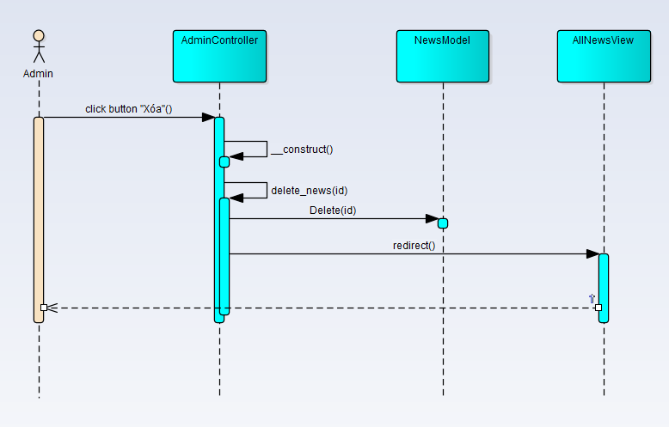

Figure 16: Delete news sequence diagram

### UC001 – 07, 09 Activate/deactivate and rate restaurant

#### Screen Design

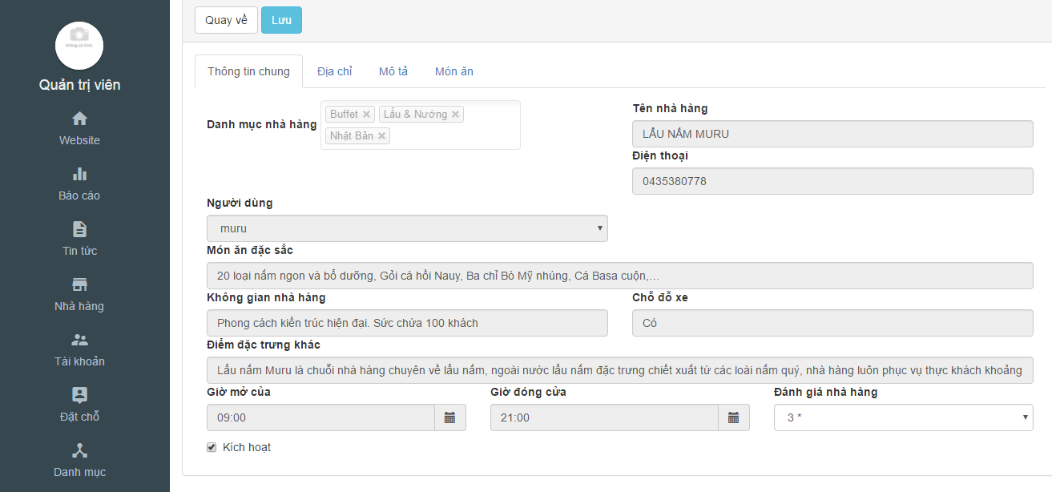

Figure 17: Activate/deactivate and rate restaurant

|  |  |  |  |  |  |  |
| --- | --- | --- | --- | --- | --- | --- |
| **No** | **Object/ Control Name** | **Object/ Control Name in English** | **Type** | **Required** | **Length** | **Description** |
| 1 | Đánh giá nhà hàng | Rate for restaurant | Combo-box | Yes | N/A | Rate for restaurant |
| 2 | Kích hoạt | Active/Deactive | Check-box | Yes | N/A | Active/Deactive for restaurant |
| 3 | Loại | Category | Integer | Yes | N/A | Category of restaurant |
| 4 | Lưu | Save | Button | Yes | N/A | Click to update restaurant |
| 5 | Quay về | Back | Button | Yes | N/A | Return to list restaurant |

Table 12: Activate/deactivate and rate restaurant

#### Sequence Diagram

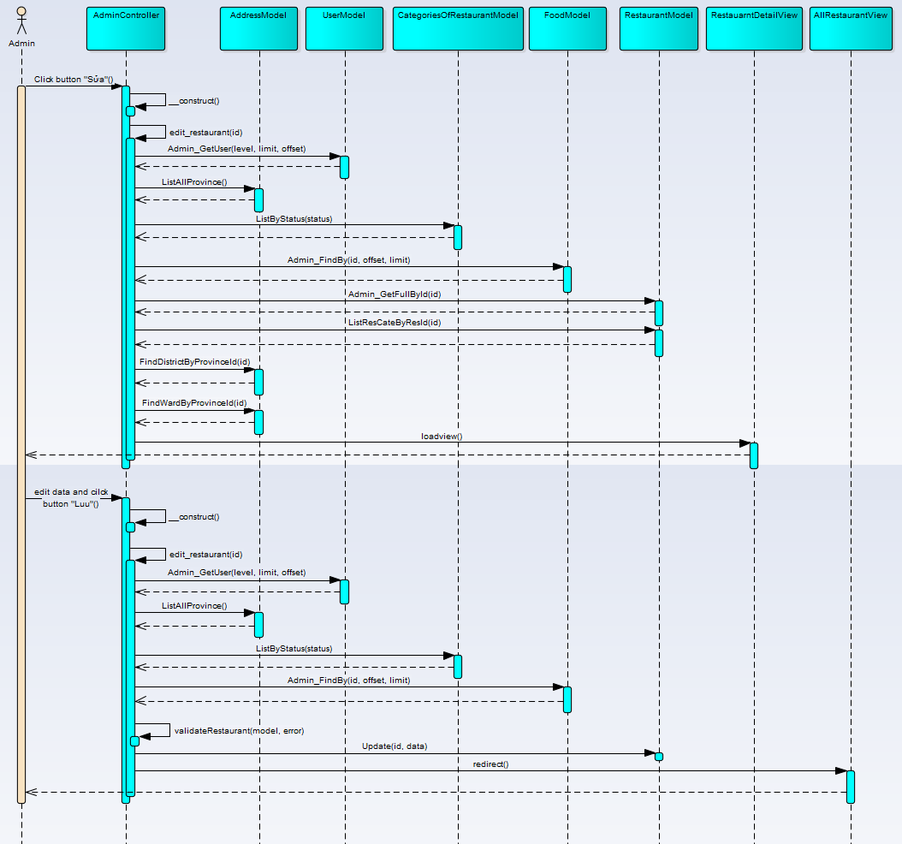

Figure 18: Activate/deactivate and rate restaurant sequence diagram

### UC001 – 08 Delete restaurant

#### Screen Design

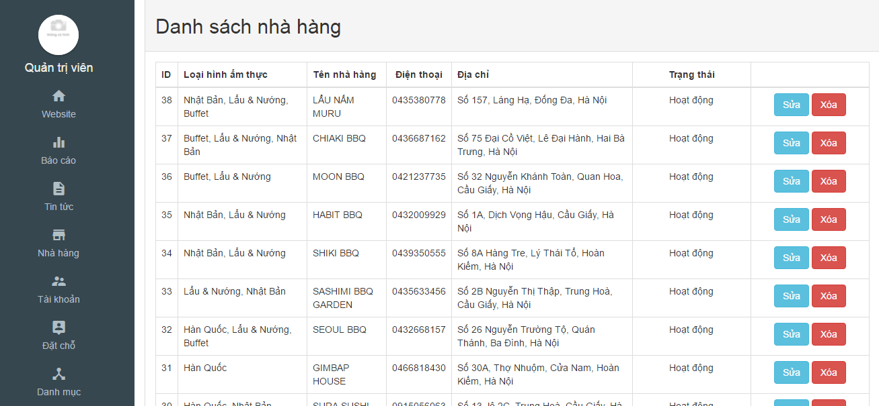

Figure 19: Detele restaurant

|  |  |  |  |  |  |  |
| --- | --- | --- | --- | --- | --- | --- |
| **No** | **Object/ Control Name** | **Object/ Control Name in English** | **Type** | **Required** | **Length** | **Description** |
| 1 | ID | ID | Integer | Yes | N/A | Id of category |
| 2 | Loại hình ẩm thực | Categories of restaurant | Text | Yes | N/A | Categories of restaurant |
| 3 | Tên nhà hàng | Name of restaurant | Text | Yes | N/A | Name of restaurant |
| 4 | Điện thoại | Phone of restaurant | Integer | Yes | N/A | Phone of restaurant |
| 5 | Địa chỉ | Address of restaurant | Text | Yes | N/A | Address of restaurant |
| 6 | Trạng thái | Status | Text | Yes | N/A | Status of restaurant |
| 7 | Xóa | Delete | Button | Yes | N/A | Click to delete restaurant |

Table 13: Delete restaurant

#### Sequence Diagram

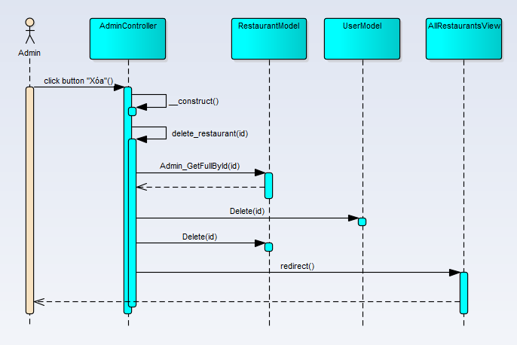

Figure 20: Delete restaurant sequence diagram

### UC001 – 10 Delete user

#### Screen Design

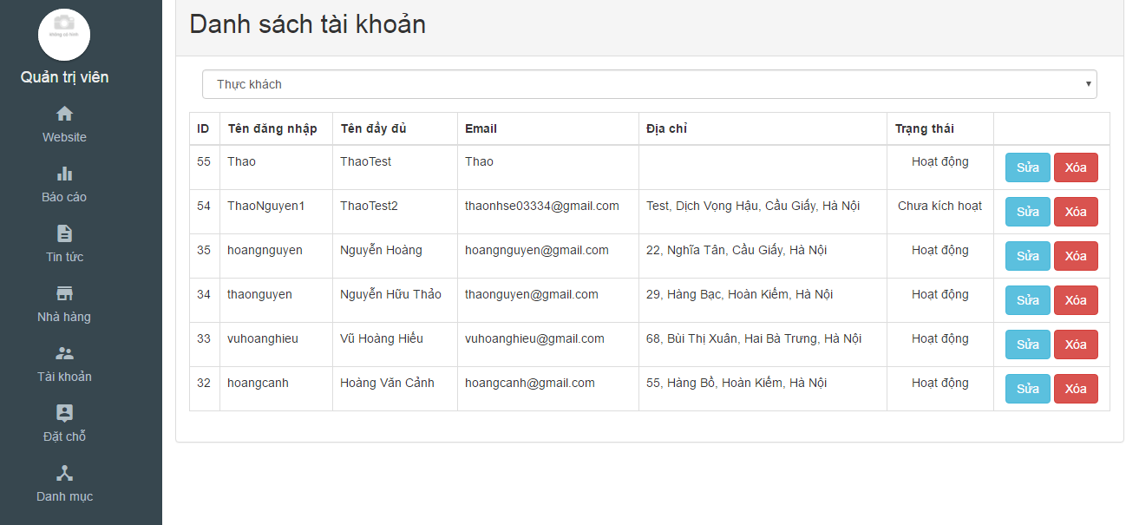

Figure 21: Delete user

|  |  |  |  |  |  |  |
| --- | --- | --- | --- | --- | --- | --- |
| **No** | **Object/ Control Name** | **Object/ Control Name in English** | **Type** | **Required** | **Length** | **Description** |
| 1 | ID | ID | Integer | Yes | N/A | Id of category |
| 2 | Tên đăng nhập | Name | Text | Yes | N/A | Name of user use to login |
| 3 | Tên đầy đủ | Fullname | Text | Yes | N/A | Fullname of user |
| 4 | Email | Email | Text | Yes | N/A | Email of user |
| 5 | Địa chỉ | Address | Text | Yes | N/A | Address of user |
| 6 | Trạng thái | Status | Text | Yes | N/A | Status of user |
| 7 | Xóa | Delete | Button | Yes | N/A | Click to delete users |

Table 14: Delete user

#### Sequence Diagram

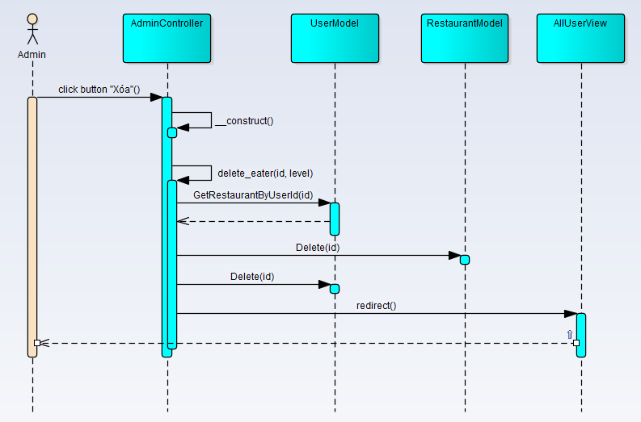

Figure 22: Delete user sequence diagram

### UC001 – 11 Activate/deactivate user

#### Screen Design

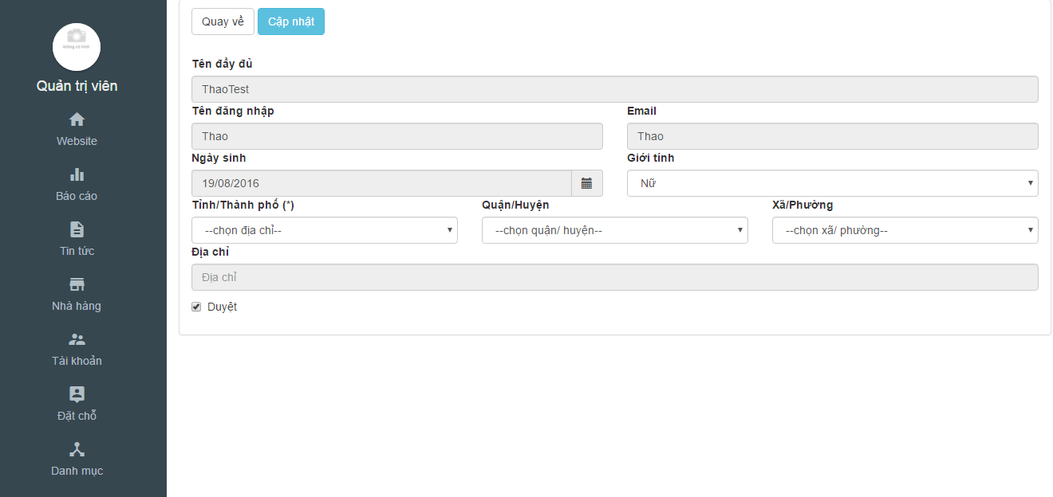

Figure 23: Activate/deactivate user

|  |  |  |  |  |  |  |
| --- | --- | --- | --- | --- | --- | --- |
| **No** | **Object/ Control Name** | **Object/ Control Name in English** | **Type** | **Required** | **Length** | **Description** |
| 2 | Duyệt | Active/Deactive | Check-box | Yes | N/A | Active/Deactive for user |
| 4 | Cập nhật | Update | Button | Yes | N/A | Click to update user |
| 5 | Quay về | Back | Button | Yes | N/A | Return to list users |

Table 15: Activate/deactivate user

#### Sequence Diagram

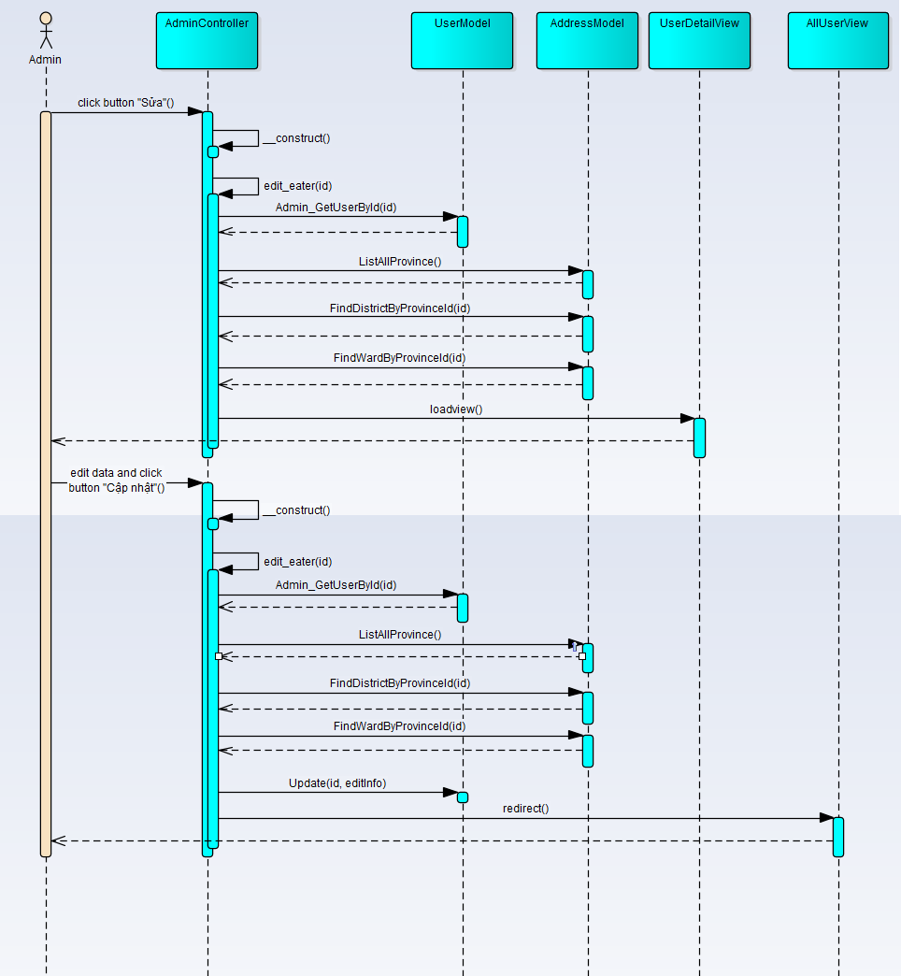

Figure 24: Activate/deactivate sequence diagram

### UC001 – 12 View all news

#### Screen Design



Figure 25: View all news

|  |  |  |  |  |  |  |
| --- | --- | --- | --- | --- | --- | --- |
| **No** | **Object/ Control Name** | **Object/ Control Name in English** | **Type** | **Required** | **Length** | **Description** |
| 1 | Tin tức | News | Button | Yes | N/A | Click to view all news |

Table 16: View all news

#### Sequence Diagram

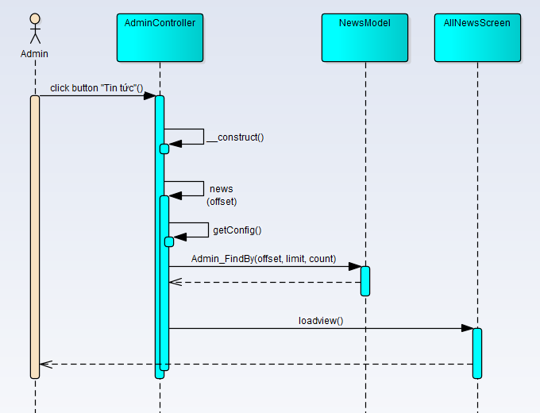

Figure 26: View all news sequence diagram

### UC001 – 13 View all categories

#### Screen Design



Figure 27: View all categories

|  |  |  |  |  |  |  |
| --- | --- | --- | --- | --- | --- | --- |
| **No** | **Object/ Control Name** | **Object/ Control Name in English** | **Type** | **Required** | **Length** | **Description** |
| 1 | Danh mục | Categories | Button | Yes | N/A | Click to view all categories |

Table 17: View all categories

#### Sequence Diagram

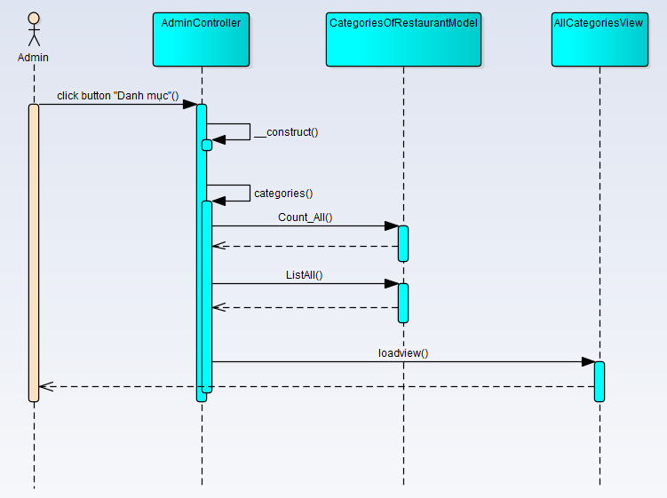

Figure 28: View all categories sequence diagram

### UC001 – 14 View all restaurants

#### Screen Design



Figure 29: View all restaurants

|  |  |  |  |  |  |  |
| --- | --- | --- | --- | --- | --- | --- |
| **No** | **Object/ Control Name** | **Object/ Control Name in English** | **Type** | **Required** | **Length** | **Description** |
| 1 | Nhà hàng | Restaurant | Button | Yes | N/A | Click to view all restaurants |

Table 18: View all restaurants

#### Sequence Diagram

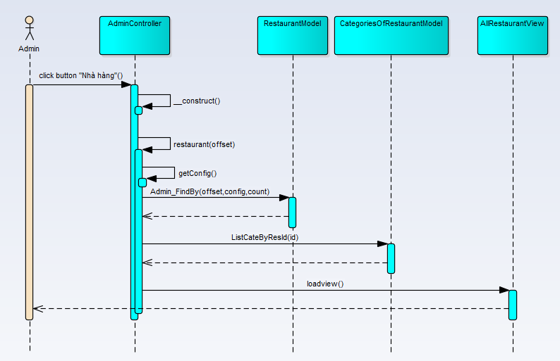

Figure 30: View all restaurants sequence diagram

### UC001 – 15 View all users

#### Screen Design



Figure 31: View all users

|  |  |  |  |  |  |  |
| --- | --- | --- | --- | --- | --- | --- |
| **No** | **Object/ Control Name** | **Object/ Control Name in English** | **Type** | **Required** | **Length** | **Description** |
| 1 | Tài khoản | User | Button | Yes | N/A | Click to view all users |

Table 19: View al users

#### Sequence Diagram

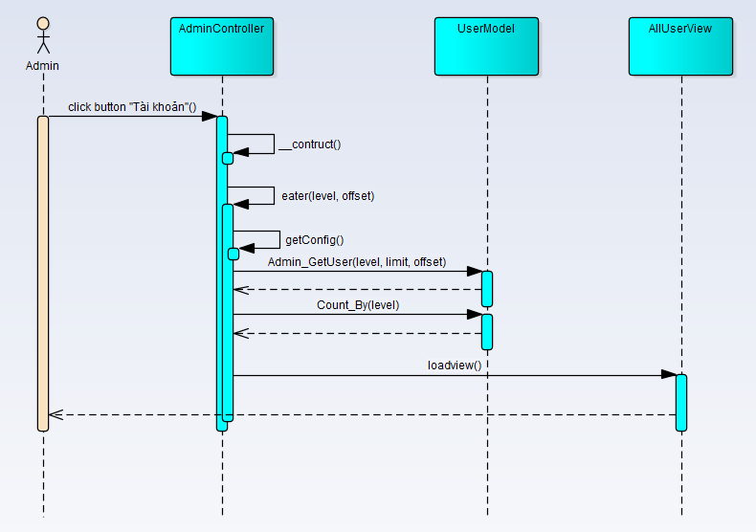

Figure 32: View all users sequence diagram

### UC001 – 16 View all booking

#### Screen Design

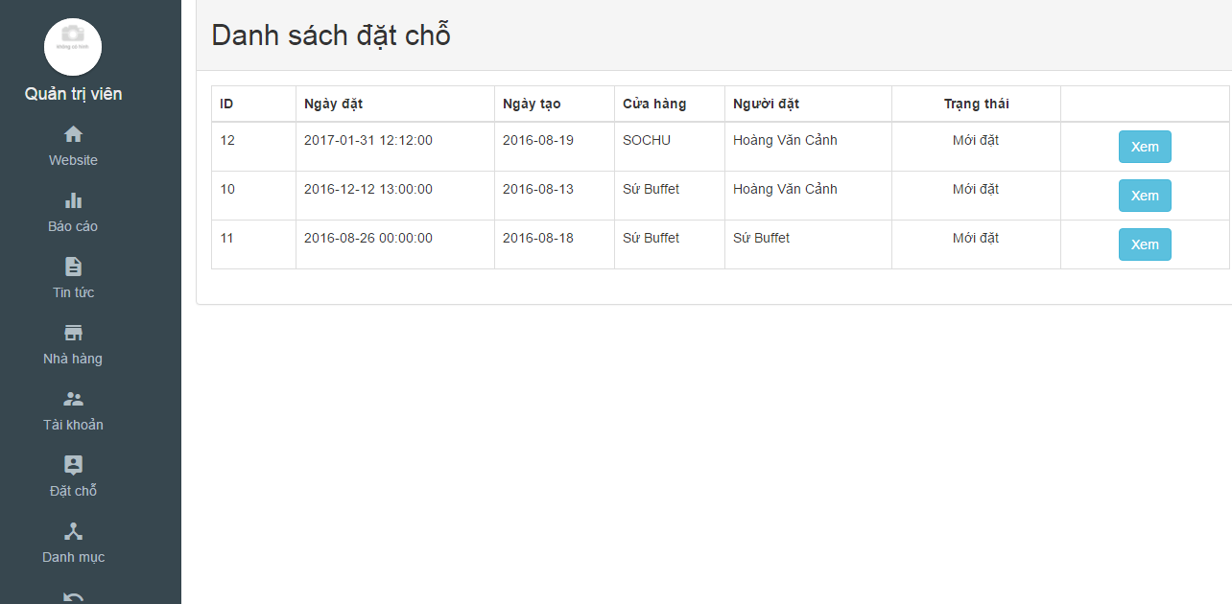

Figure 33: View all booking

|  |  |  |  |  |  |  |
| --- | --- | --- | --- | --- | --- | --- |
| **No** | **Object/ Control Name** | **Object/ Control Name in English** | **Type** | **Required** | **Length** | **Description** |
| 1 | Đặt chỗ | Booking | Button | Yes | N/A | Click to view all booking |

Table 20: View all booking

#### Sequence Diagram

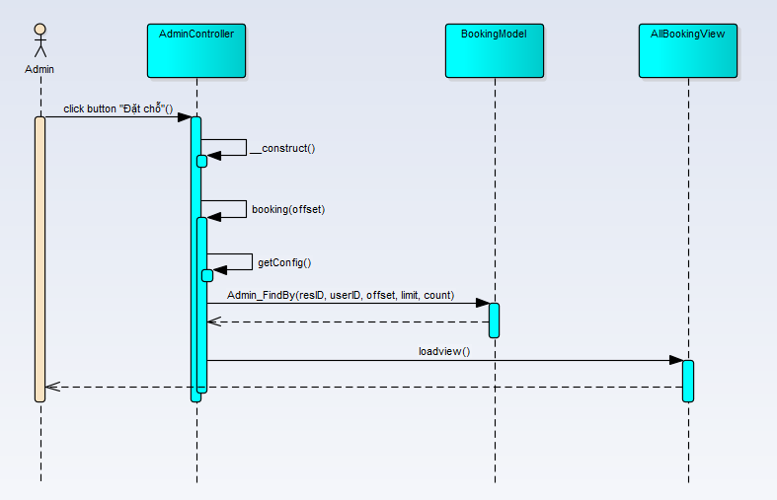

Figure 34: View all booking sequence diagram

### UC001 – 17 View detail booking

#### Screen Design

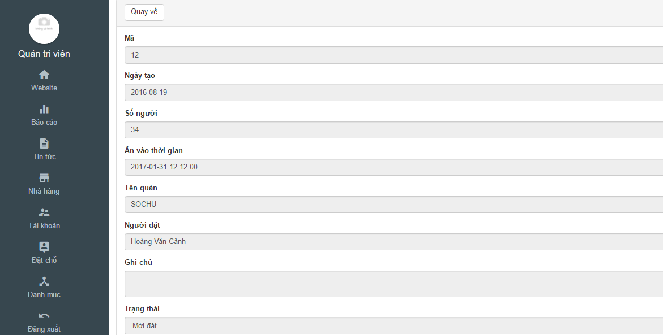

Figure 35: View detail booking

|  |  |  |  |  |  |  |
| --- | --- | --- | --- | --- | --- | --- |
| **No** | **Object/ Control Name** | **Object/ Control Name in English** | **Type** | **Required** | **Length** | **Description** |
| 1 | Quay về | Back | Button | Yes | N/A | Click to return all booking |

Table 21: View detail booking

#### Sequence Diagram

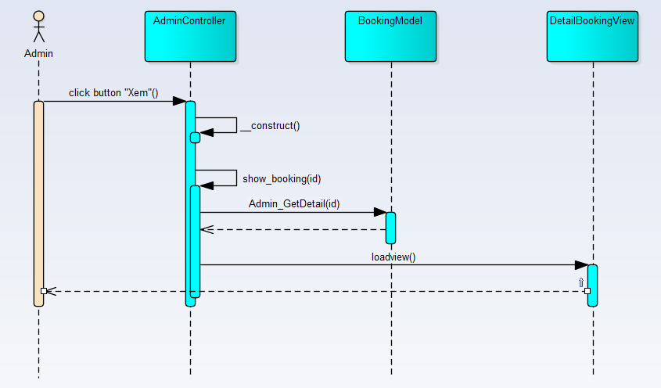

Figure 36: View detail booking sequence diagram

### UC001 – 18 Report statistics

#### Screen Design

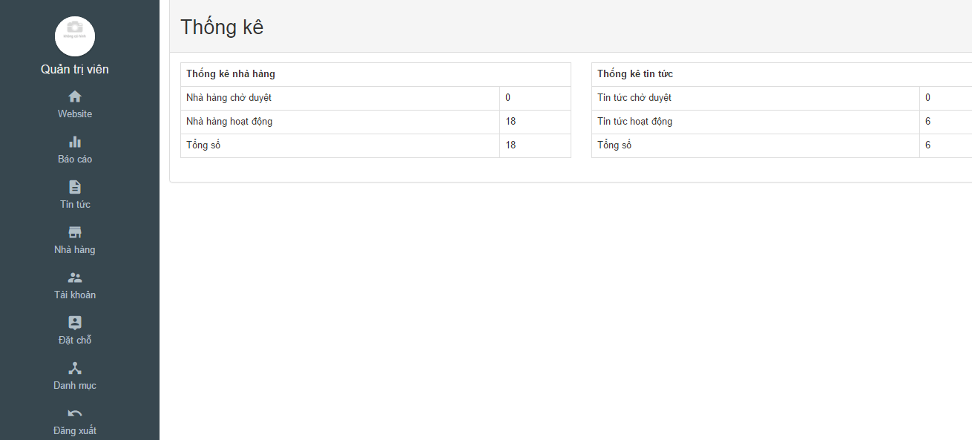

Figure 37: Report statistics

|  |  |  |  |  |  |  |
| --- | --- | --- | --- | --- | --- | --- |
| **No** | **Object/ Control Name** | **Object/ Control Name in English** | **Type** | **Required** | **Length** | **Description** |
| 1 | Báo cáo | Back | Button | Yes | N/A | Click to view report statistics |

Table 22: Report statistics

#### Sequence Diagram

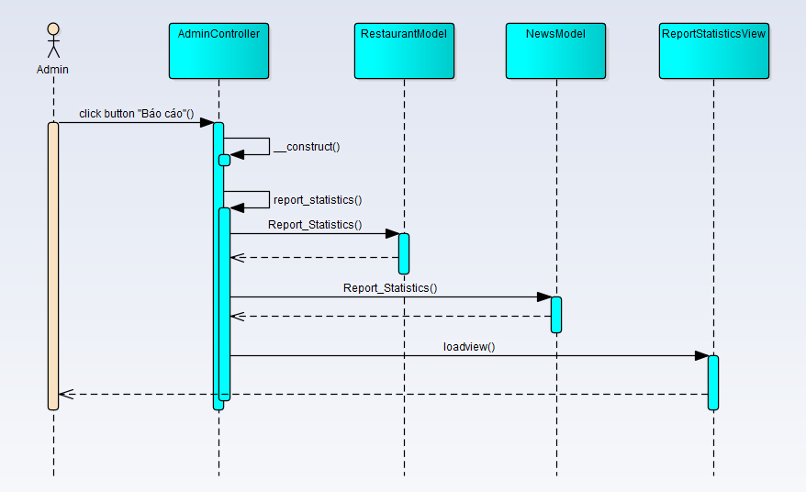

Figure 38: Report statistics sequence diagram

## UC002 Customer Management

### Class Diagram

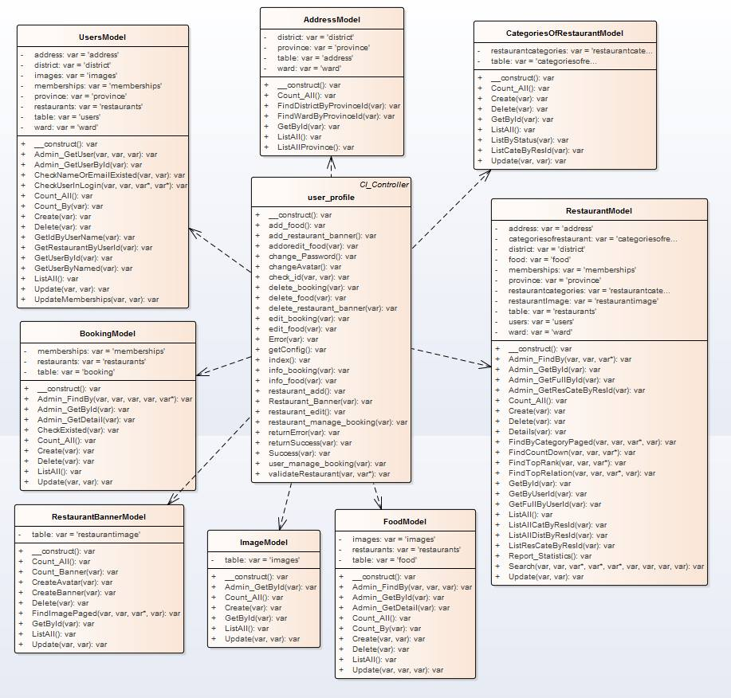

Figure 39: Customer management class diagram

### UC002 – 01 Login

#### Screen Design

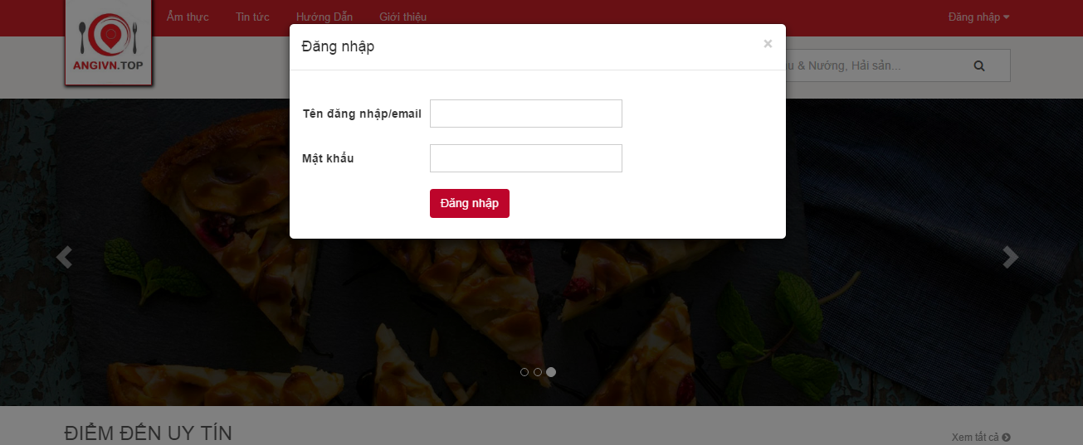

Figure 40: Login

|  |  |  |  |  |  |  |
| --- | --- | --- | --- | --- | --- | --- |
| **No** | **Object/ Control Name** | **Object/ Control Name in English** | **Type** | **Required** | **Length** | **Description** |
| 1 | Tên đăng nhập/ Email | Username/Email | Text-box | Yes | N/A | Input username/ email |
| 2 | Mật khẩu | Password | Password | Yes | N/A | Input password |
| 3 | Đăng nhập | Login | Button | Yes | N/A | Click to login website |

Table 23: Login

#### Sequence diagram

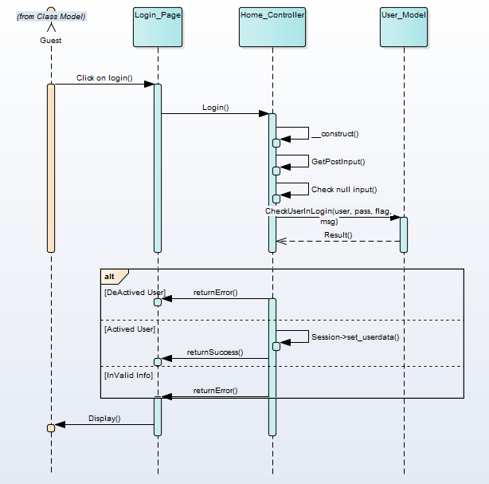

Figure 41: Login sequence diagram

### UC002 – 02 Log out

#### Screen Design

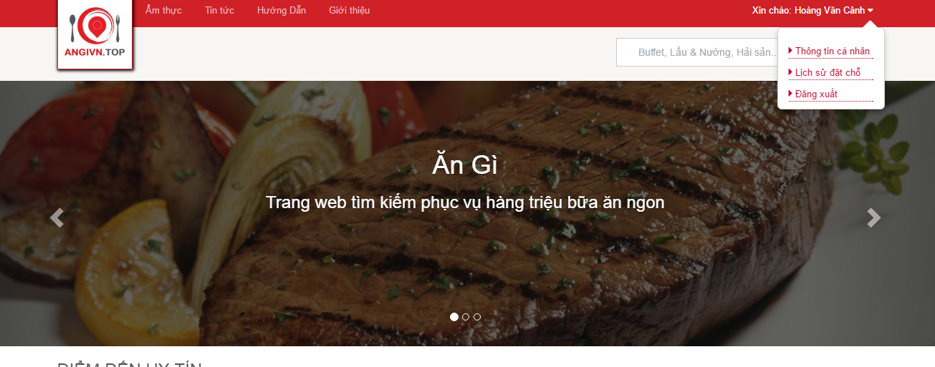

Figure 42: Logout

|  |  |  |  |  |  |  |
| --- | --- | --- | --- | --- | --- | --- |
| **No** | **Object/ Control Name** | **Object/ Control Name in English** | **Type** | **Required** | **Length** | **Description** |
| 1 | Đăng xuất | Logout | Button | Yes | N/A | Click to logout website |

Table 24: Logout

#### Sequence diagram

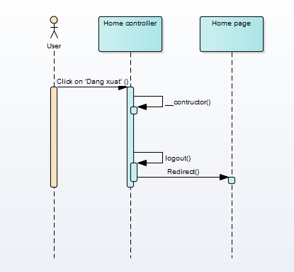

Figure 43: Logout sequence diagram

### UC002 – 03 View account

#### Screen Design

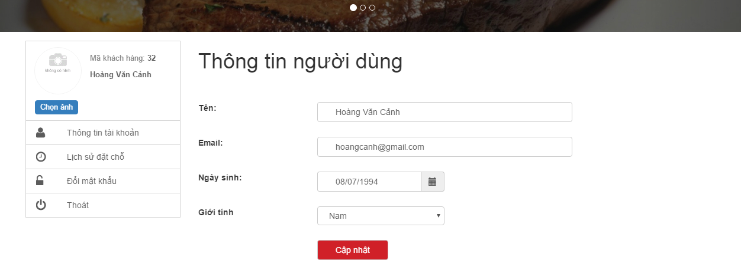

Figure 44: View account

|  |  |  |  |  |  |  |
| --- | --- | --- | --- | --- | --- | --- |
| **No** | **Object/ Control Name** | **Object/ Control Name in English** | **Type** | **Required** | **Length** | **Description** |
| 1 | Thông tin tài khoản | Account profile | Button | Yes | N/A | Click to redirect account profile screen |
| 2 | Tên | Name | Textbox | Yes | N/A | Name of user |
| 3 | Email | Email | Textbox | Yes | N/A | Email of user |
| 4 | Ngày sinh | Date of birth | Date-picker | Yes | N/A | Date of birth of user |
| 5 | Giới tính | Gender | Combox | Yes | N/A | Gender of user |
| 6 | Cập nhật | Update | Button | Yes | N/A | Click to update information of user |

Table 25: View account

#### Sequence diagram

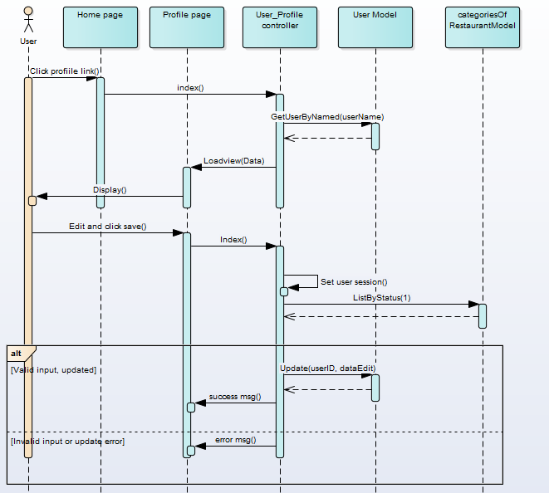

Figure 45: View account sequence diagram

### UC002 – 04 Update account

#### Screen Design



Figure 46: Update account

|  |  |  |  |  |  |  |
| --- | --- | --- | --- | --- | --- | --- |
| **No** | **Object/ Control Name** | **Object/ Control Name in English** | **Type** | **Required** | **Length** | **Description** |
| 1 | Thông tin tài khoản | Account profile | Button | Yes | N/A | Click to redirect account profile screen |
| 2 | Tên | Name | Textbox | Yes | N/A | Name of user |
| 3 | Email | Email | Textbox | Yes | N/A | Email of user |
| 4 | Ngày sinh | Date of birth | Date-picker | Yes | N/A | Date of birth of user |
| 5 | Giới tính | Gender | Combox | Yes | N/A | Gender of user |
| 6 | Cập nhật | Update | Button | Yes | N/A | Click to update information of user |

Table 26: Update account

#### Sequence diagram



Figure 47: Update account sequence diagram

### UC002 – 05 Update password

#### Screen Design

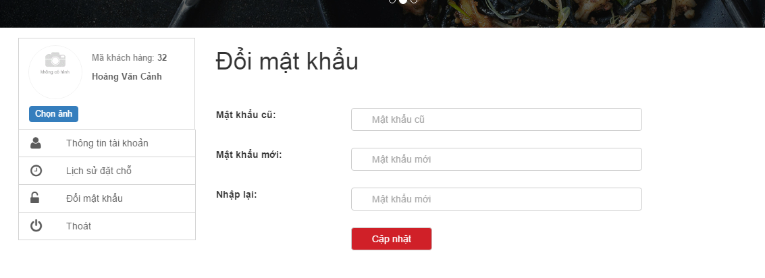

Figure 48: Update password

|  |  |  |  |  |  |  |
| --- | --- | --- | --- | --- | --- | --- |
| **No** | **Object/ Control Name** | **Object/ Control Name in English** | **Type** | **Required** | **Length** | **Description** |
| 1 | Đổi mật khẩu | Change password | Button | Yes | N/A | Click to redirect change password screen |
| 2 | Mật khẩu cũ | Old password | Text-box | Yes | N/A | Old password of user |
| 3 | Mật khẩu mới | New password | Text-box | Yes | >= 6 character | New password of user |
| 4 | Nhập lại | Confirm password | Date-picker | Yes | N/A | Confirm password |
| 5 | Cập nhật | Update | Button | Yes | N/A | Click to change password of user |

Table 27: Update password

#### Sequence diagram

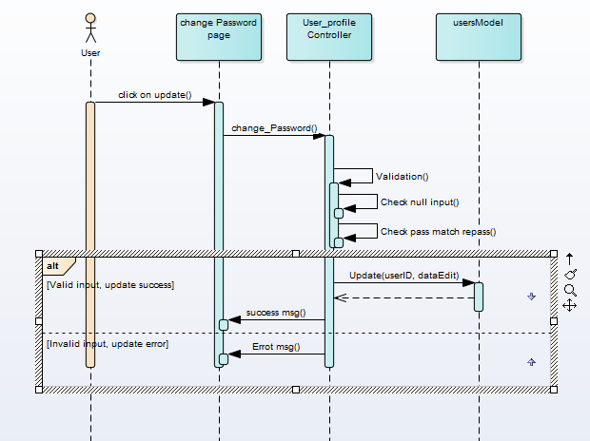

Figure 49: Update password sequence diagram

### UC002 – 06 Book restaurant

#### Screen Design

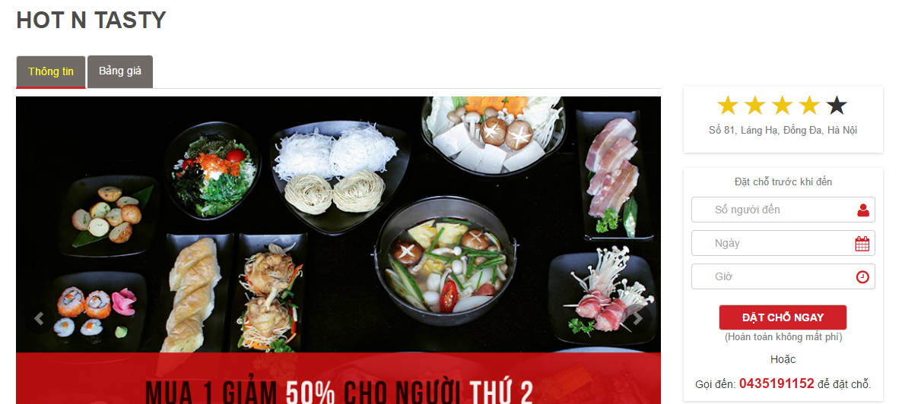

Figure 50: Book restaurant

|  |  |  |  |  |  |  |
| --- | --- | --- | --- | --- | --- | --- |
| **No** | **Object/ Control Name** | **Object/ Control Name in English** | **Type** | **Required** | **Length** | **Description** |
| 1 | Số người đến | Number of customer | Textbox | Yes | N/A | Input number of customer |
| 2 | Ngày | Date | Textbox | Yes | N/A | Date of booking |
| 3 | Giờ | Time | Textbox | Yes | N/A | Time of booking |
| 4 | Đặt chỗ ngay | Booking now | Button | Yes | N/A | Click to send booking |

Table 28: Booking restaurant

#### Sequence diagram

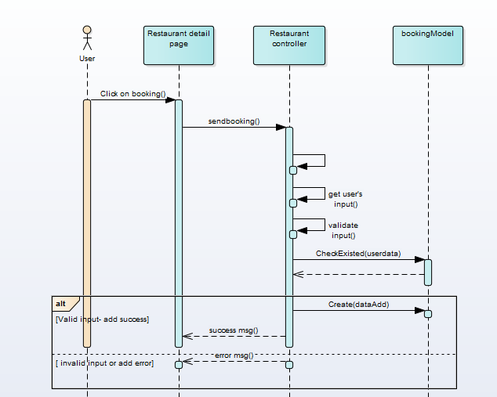

Figure 51: Booking restaurant sequence diagram

### UC002 – 07 Upload avatar

#### Screen Design

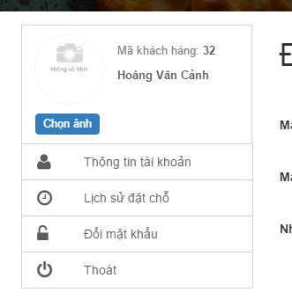

Figure 52: Select image

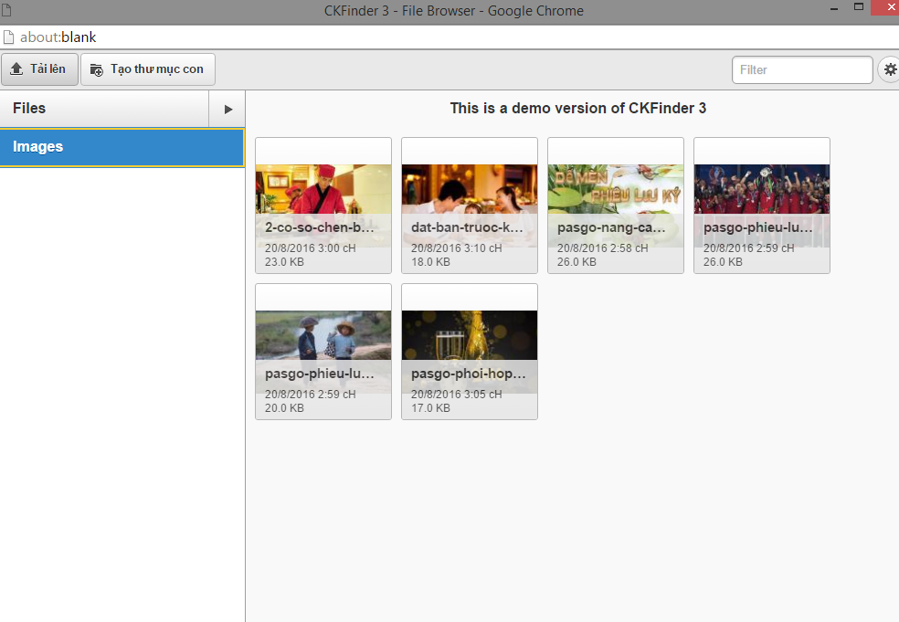

Figure 53: Upload and select image

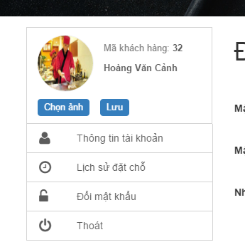

Figure 54: Save new avata

|  |  |  |  |  |  |  |
| --- | --- | --- | --- | --- | --- | --- |
| **No** | **Object/ Control Name** | **Object/ Control Name in English** | **Type** | **Required** | **Length** | **Description** |
| 1 | Chọn ảnh | Choose image | Button | Yes | N/A | Click to change avatar |
| 2 | Lưu | Save | Button | Yes | N/A | Click to save new avatar |

Table 29: Update avata

#### Sequence diagram

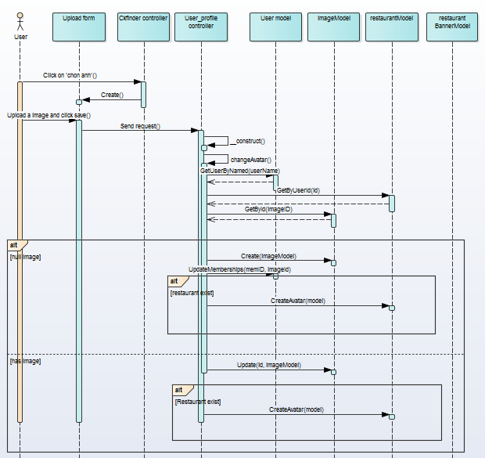

Figure 55: Upload avata sequence diagram

### UC002 – 08 View booking history

#### Screen Design

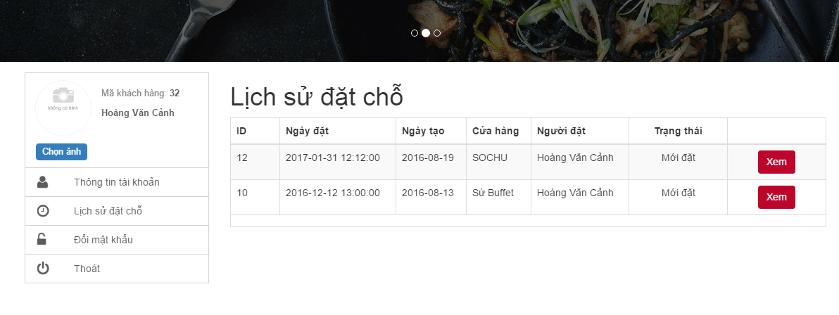

Figure 56:View booking history

|  |  |  |  |  |  |  |
| --- | --- | --- | --- | --- | --- | --- |
| **No** | **Object/ Control Name** | **Object/ Control Name in English** | **Type** | **Required** | **Length** | **Description** |
| 1 | Lịch sử đặt chỗ | History of booking | Button | Yes | N/A | Click to redirect history of booking screen |
| 2 | Xem | View | Button | Yes | N/A | Click to view booking detail |

Table 30: View booking history

#### Sequence diagram

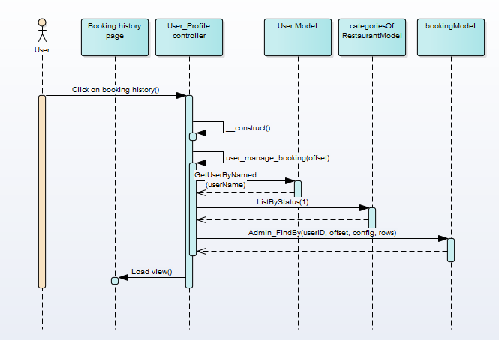

Figure 57: View booking history sequence diagram

## UC003 Restaurant Owner Management

### Class Diagram



Figure 58: Restaurant Owner management

### UC003 – 01 Add restaurant information

#### Screen Design

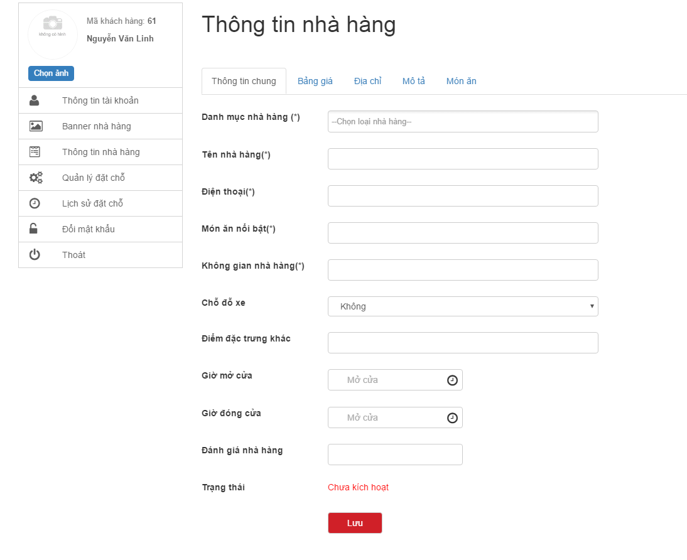

Figure 59: Add restaurant information

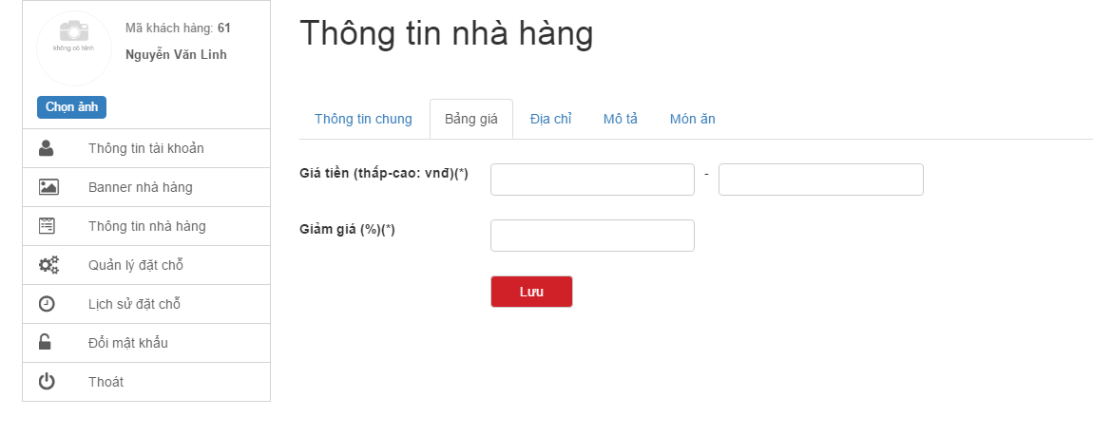

Figure 60: Add average price

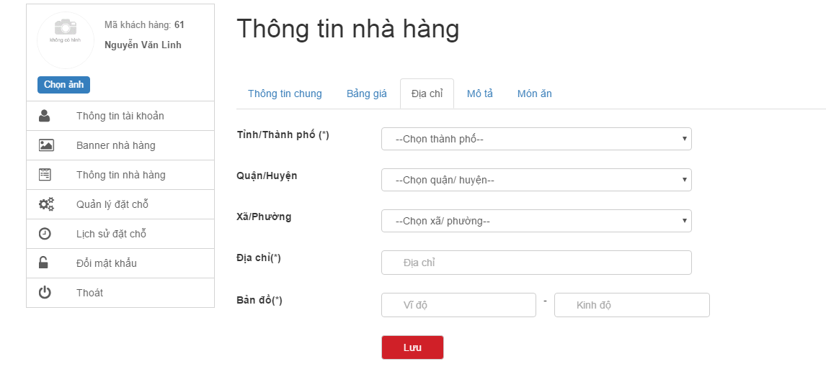

Figure 61: Add restaurant address

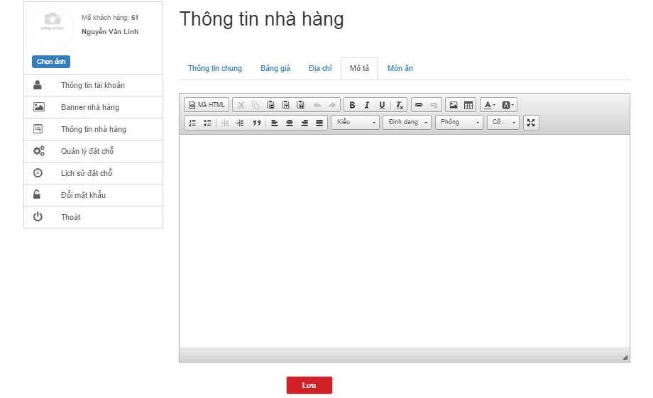

Figure 62: Add description for restaurant

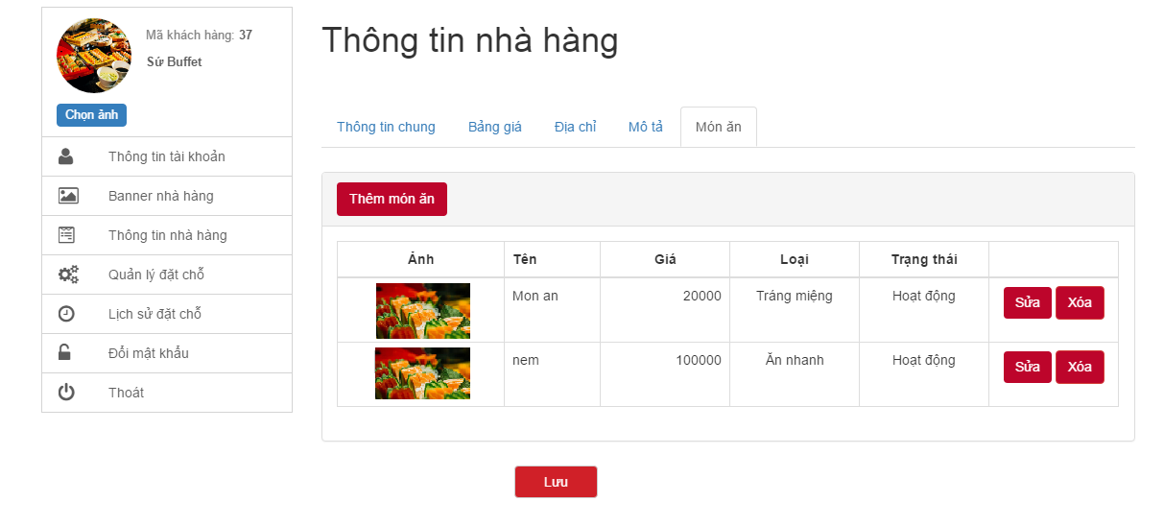

Figure 63: Add foods

|  |  |  |  |  |  |  |
| --- | --- | --- | --- | --- | --- | --- |
| **No** | **Object/ Control Name** | **Object/ Control Name in English** | **Type** | **Required** | **Length** | **Description** |
| 1 | Thông tin nhà hàng | Restaurant information | Button | Yes | N/A | Click to redirect restaurant information screen |
| 2 | Danh mục nhà hàng | Categories of restaurant | Combo-box | Yes | N/A | Select categories of restaurant |
| 3 | Tên nhà hàng | Name of restaurant | Textbox | Yes | N/A | Input name of restaurant |
| 4 | Điện thoại | Phone | Textbox | Yes | N/A | Input phone of restaurant |
| 5 | Món ăn nổi bật | Favourite foods | Textbox | Yes | N/A | Input favourite foods of restaurant |
| 6 | Không gian nhà hàng | Restaurant space | Textbox | Yes | N/A | Input restaurant space |
| 7 | Chỗ đỗ xe | Parking | Combo-box | Yes | N/A | Select parking of restaurant |
| 8 | Điểm đặc trưng khác | Others | Textbox | No | N/A | Input others of restaurant |
| 9 | Giờ mở cửa | Open time | Textbox | Yes | N/A | Input open time of restaurant |
| 10 | Giờ đóng cửa | Close time | Textbox | Yes | N/A | Input close time of restaurant |
| 11 | Giá tiền (thấp - cao) | Price (min-max) | Textbox | Yes | N/A | Input price of restaurant |
| 12 | Giảm giá | Discount | Textbox | Yes | N/A | Input discount of restaurant |
| 13 | Tỉnh/ thành phố | Province | Combo-box | Yes | N/A | Select province of restaurant |
| 14 | Quận/ huyện | District | Combo-box | Yes | N/A | Select district of restaurant |
| 15 | Xã/ phường | Ward | Combo-box | Yes | N/A | Select ward of restaurant |
| 16 | Địa chỉ | Address | Textbox | Yes | N/A | Input address of restaurant |
| 17 | Bản đồ | Map | Textbox | Yes | N/A | Input latitude and longitude of restaurant |
| 18 | Mô tả | Description | TextArea | Yes | N/A | Input description of restaurant |
| 19 | Lưu | Save | Button | Yes | N/A | Click to add restaurant |

Table 31: Add restaurant information

#### Sequence diagram

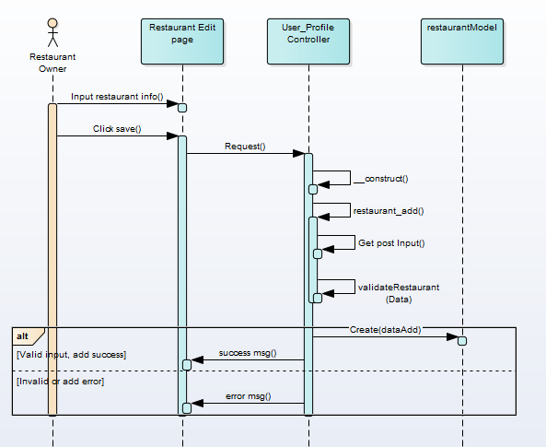

Figure 64: Add restaurant information sequence diagram

### UC003 – 02 Update restaurant info

#### Screen Design

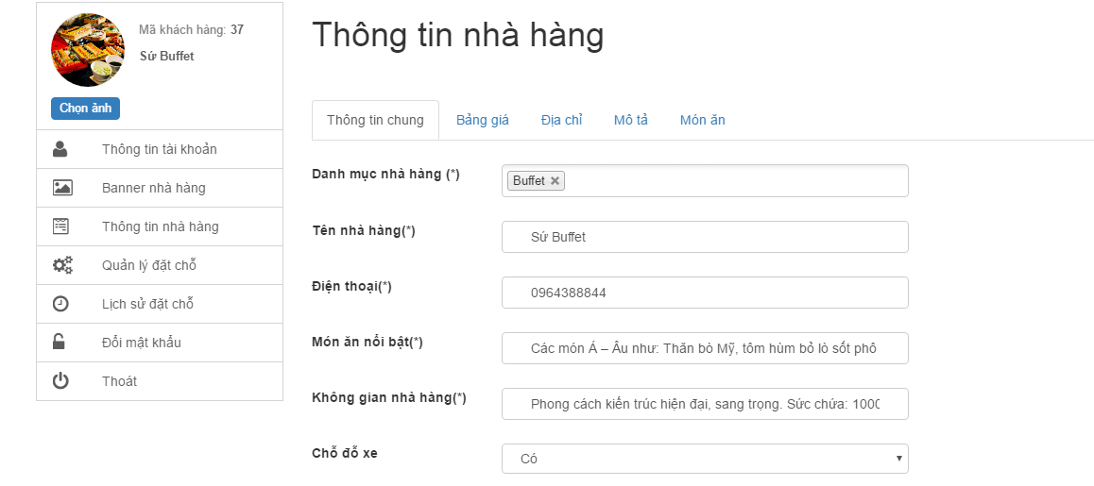

Figure 65: Update restaurant information

|  |  |  |  |  |  |  |
| --- | --- | --- | --- | --- | --- | --- |
| **No** | **Object/ Control Name** | **Object/ Control Name in English** | **Type** | **Required** | **Length** | **Description** |
| 1 | Thông tin nhà hàng | Restaurant information | Button | Yes | N/A | Click to redirect restaurant information screen |
| 2 | Danh mục nhà hàng | Categories of restaurant | Combo-box | Yes | N/A | Select categories of restaurant |
| 3 | Tên nhà hàng | Name of restaurant | Textbox | Yes | N/A | Input name of restaurant |
| 4 | Điện thoại | Phone | Textbox | Yes | N/A | Input phone of restaurant |
| 5 | Món ăn nổi bật | Favourite foods | Textbox | Yes | N/A | Input favourite foods of restaurant |
| 6 | Không gian nhà hàng | Restaurant space | Textbox | Yes | N/A | Input restaurant space |
| 7 | Chỗ đỗ xe | Parking | Combo-box | Yes | N/A | Select parking of restaurant |
| 8 | Điểm đặc trưng khác | Others | Textbox | No | N/A | Input others of restaurant |
| 9 | Giờ mở cửa | Open time | Textbox | Yes | N/A | Input open time of restaurant |
| 10 | Giờ đóng cửa | Close time | Textbox | Yes | N/A | Input close time of restaurant |
| 11 | Giá tiền (thấp - cao) | Price (min-max) | Textbox | Yes | N/A | Input price of restaurant |
| 12 | Giảm giá | Discount | Textbox | Yes | N/A | Input discount of restaurant |
| 13 | Tỉnh/ thành phố | Province | Combo-box | Yes | N/A | Select province of restaurant |
| 14 | Quận/ huyện | District | Combo-box | Yes | N/A | Select district of restaurant |
| 15 | Xã/ phường | Ward | Combo-box | Yes | N/A | Select ward of restaurant |
| 16 | Địa chỉ | Address | Textbox | Yes | N/A | Input address of restaurant |
| 17 | Bản đồ | Map | Textbox | Yes | N/A | Input latitude and longitude of restaurant |
| 18 | Mô tả | Description | TextArea | Yes | N/A | Input description of restaurant |
| 19 | Lưu | Save | Button | Yes | N/A | Click to add restaurant |

Table 32: Update resturant information

#### Sequence diagram

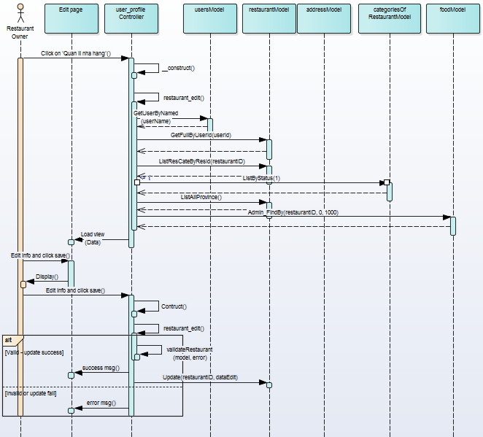

Figure 66: Update restaurant information sequence diagram

### UC003 – 03 Add restaurant banner

#### Screen Design

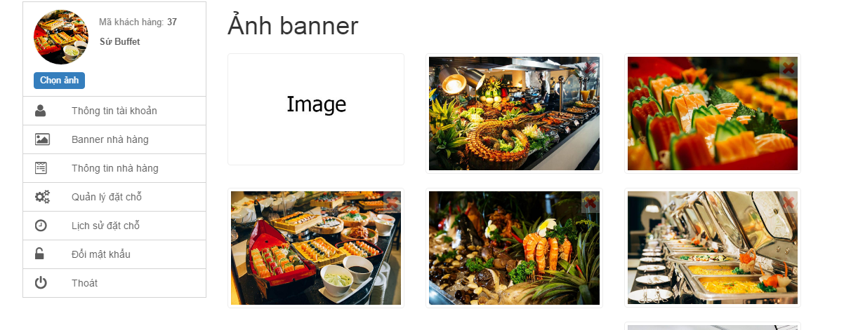

Figure 67: Add restaurant banner

|  |  |  |  |  |  |  |
| --- | --- | --- | --- | --- | --- | --- |
| **No** | **Object/ Control Name** | **Object/ Control Name in English** | **Type** | **Required** | **Length** | **Description** |
| 1 | Banner nhà hàng | Banner of restaurant | Button | Yes | N/A | Click to view all banners of restaurant |
| 2 | Image | Image | Button | Yes | N/A | Click to add banner of restaurant |

Table 33: Add restaurant banner

#### Sequence diagram

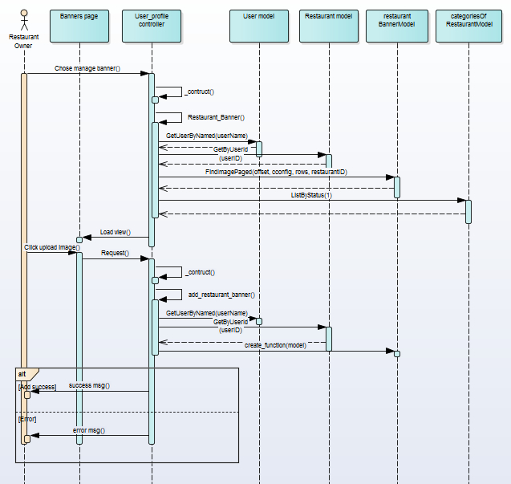

Figure 68: Add restaurant banner sequence diagram

### UC003 – 04 Delete restaurant banner

#### Screen Design

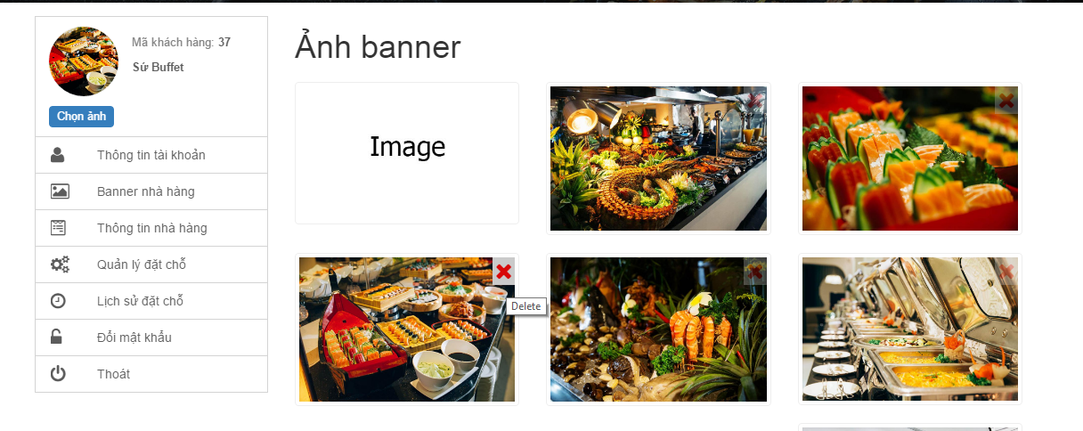

Figure 69: Delete restaurant banner

|  |  |  |  |  |  |  |
| --- | --- | --- | --- | --- | --- | --- |
| **No** | **Object/ Control Name** | **Object/ Control Name in English** | **Type** | **Required** | **Length** | **Description** |
| 1 | Delete (X) | Delete (X) | Button | Yes | N/A | Click to delete banners of restaurant |

Table 34: Delete restaurant banner

#### Sequence diagram

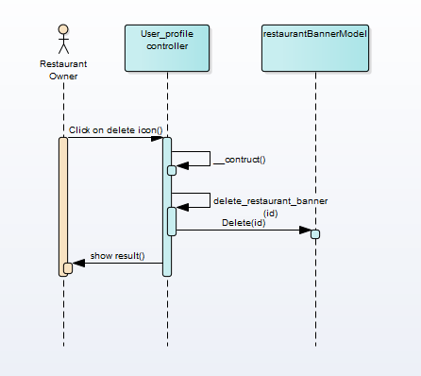

Figure 70: Delete restaurant banenr

### UC003 – 05 Add food

#### Screen Design



Figure 71: List of foods

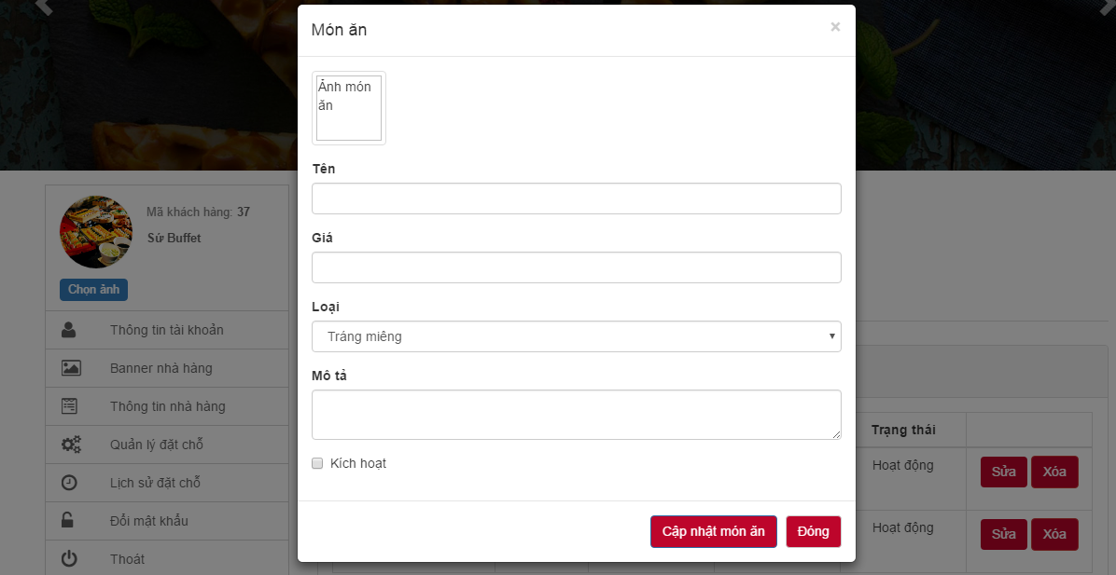

Figure 72: Add new food

|  |  |  |  |  |  |  |
| --- | --- | --- | --- | --- | --- | --- |
| **No** | **Object/ Control Name** | **Object/ Control Name in English** | **Type** | **Required** | **Length** | **Description** |
| 1 | Ảnh món ăn | Image | Button | Yes | N/A | Click to add image of food |
| 2 | Tên | Name | Textbox | Yes | N/A | Input name of food |
| 3 | Giá | Price | Textbox | Yes | N/A | Input price of food |
| 4 | Loại | Category | Combo-box | Yes | N/A | Select category of food |
| 5 | Mô tả | Description | Textbox | No | N/A | Input description of food |
| 6 | Kích hoạt | Active | Check-box | Yes | N/A | Select to active/deactive food |
| 7 | Cập nhật món ăn | Update food | Button | Yes | N/A | Click to add food |
| 8 | Đóng | Close | Button | Yes | N/A | Click to return list foods screen |

Table 35: Add new food

#### Sequence diagram

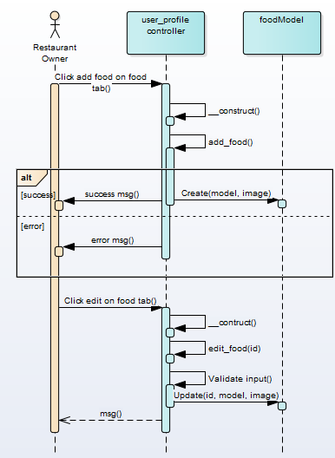

Figure 73: Add new food sequence diagram

### UC003 – 06 Update food information

#### Screen Design



Figure 74: Update food’s information

|  |  |  |  |  |  |  |
| --- | --- | --- | --- | --- | --- | --- |
| **No** | **Object/ Control Name** | **Object/ Control Name in English** | **Type** | **Required** | **Length** | **Description** |
| 1 | Ảnh món ăn | Image | Button | Yes | N/A | Click to add image of food |
| 2 | Tên | Name | Textbox | Yes | N/A | Input name of food |
| 3 | Giá | Price | Textbox | Yes | N/A | Input price of food |
| 4 | Loại | Category | Combo-box | Yes | N/A | Select category of food |
| 5 | Mô tả | Description | Textbox | No | N/A | Input description of food |
| 6 | Kích hoạt | Active | Check-box | Yes | N/A | Select to active/deactive food |
| 7 | Cập nhật món ăn | Update food | Button | Yes | N/A | Click to add food |
| 8 | Đóng | Close | Button | Yes | N/A | Click to return list foods screen |

Table 36: Update food’s information

#### Sequence diagram



Figure 75: Update food’s information sequence diagram

### UC003 – 07 Update booking status

#### Screen Design

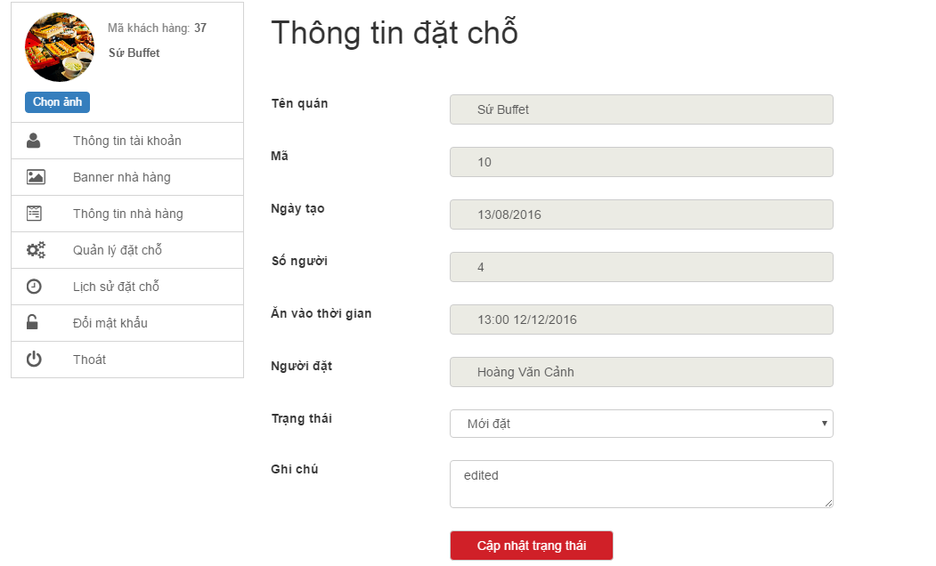

Figure 76: Update booking status

|  |  |  |  |  |  |  |
| --- | --- | --- | --- | --- | --- | --- |
| **No** | **Object/ Control Name** | **Object/ Control Name in English** | **Type** | **Required** | **Length** | **Description** |
| 1 | Trạng thái | Status | Combo-box | Yes | N/A | Select status of booking |
| 2 | Ghi chú | Note | TextArea | No | N/A | Input note of booking |
| 3 | Cập nhật trạng thái | Update status | Button | Yes | N/A | Click to update booking |

Table 37: Update booking status

#### Sequence diagram

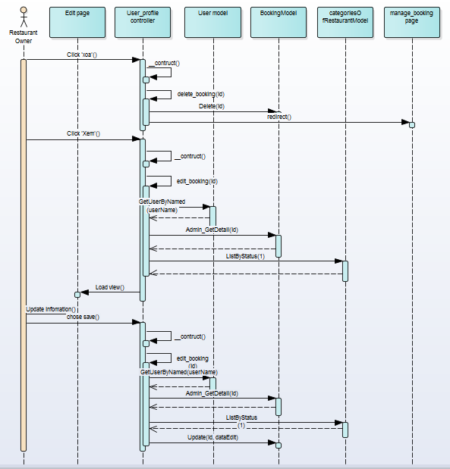

Figure 77: Update booking status sequence diagram

### UC002 – 08 View booking history

#### Screen Design

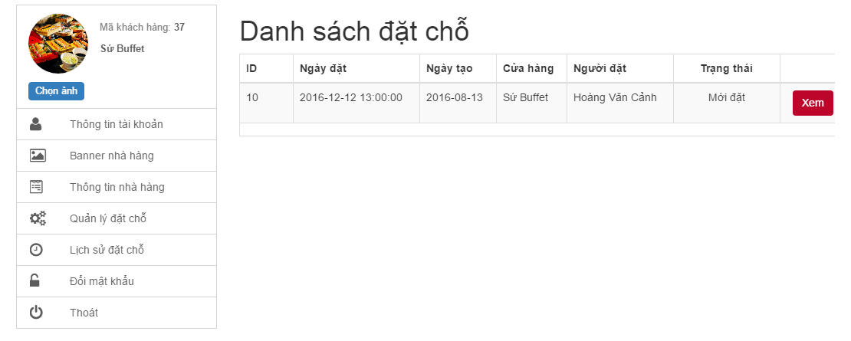

Figure 78: View booking history

|  |  |  |  |  |  |  |
| --- | --- | --- | --- | --- | --- | --- |
| **No** | **Object/ Control Name** | **Object/ Control Name in English** | **Type** | **Required** | **Length** | **Description** |
| 1 | Quản lý đặt chỗ | Booking manager | Button | Yes | N/A | Click to display list booking of restaurant |

Table 38: View booking history

#### Sequence diagram

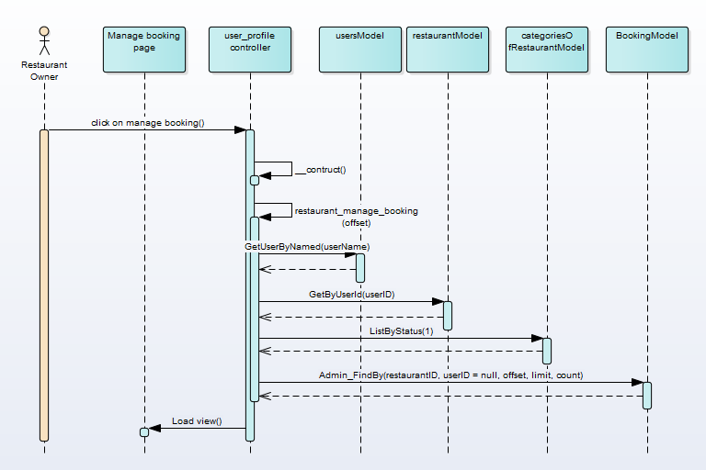

Figure 79: View booking history sequence diagram

## UC004 Guest

### Class Diagram

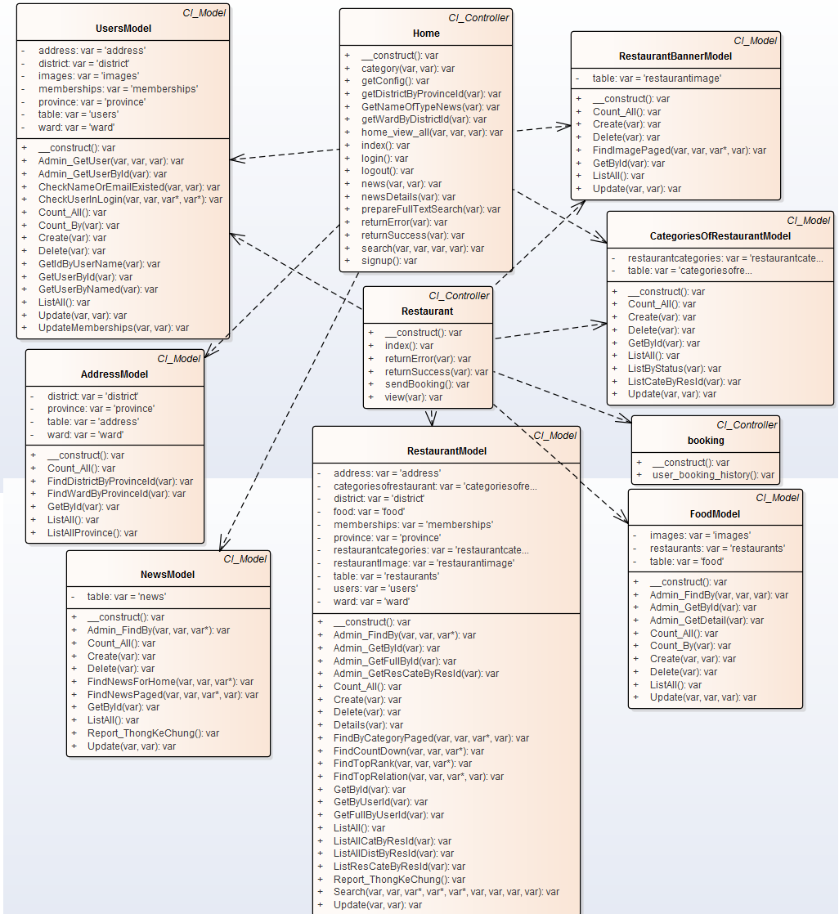

Figure 80: Guest class diagram

### UC004 – 01 Register

#### Screen Design

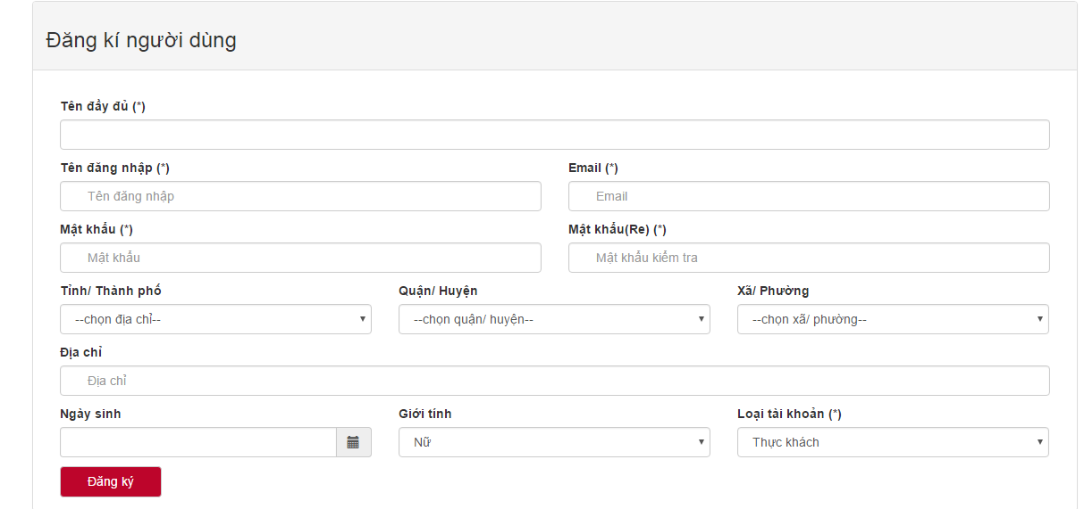

Figure 81: Register

|  |  |  |  |  |  |  |
| --- | --- | --- | --- | --- | --- | --- |
| **No** | **Object/ Control Name** | **Object/ Control Name in English** | **Type** | **Required** | **Length** | **Description** |
| 1 | Tên đầy đủ | Full name | Textbox | Yes | N/A | Input full name |
| 2 | Tên đăng nhập | Username | Textbox | Yes | >=6 characters | Input username |
| 3 | Email | Email | Textbox | Yes | N/A | Input email |
| 4 | Mật khẩu | Password | Textbox | Yes | >=6 characters | Input password |
| 5 | Mật khẩu(Re) | Confirm password | Textbox | Yes | N/A | Input confirm password |
| 6 | Tỉnh/ thành phố | Province | Combo-box | No | N/A | Select province |
| 7 | Quận/ huyện | District | Combo-box | No | N/A | Select district |
| 8 | Xã/ phường | Ward | Conbo-box | No | N/A | Select ward |
| 9 | Ngày sinh | Date of birth | Date-picker | No | N/A | Select date of birth |
| 10 | Giới tính | Gender | Combo-box | No | N/A | Select gender |
| 11 | Loai tài khoản | Type of account | Combo-box | No | N/A | Select type of account |
| 12 | Đăng ký | Register | Button | Yes | N/A | Click to register |

Table 39: Register

#### Sequence diagram

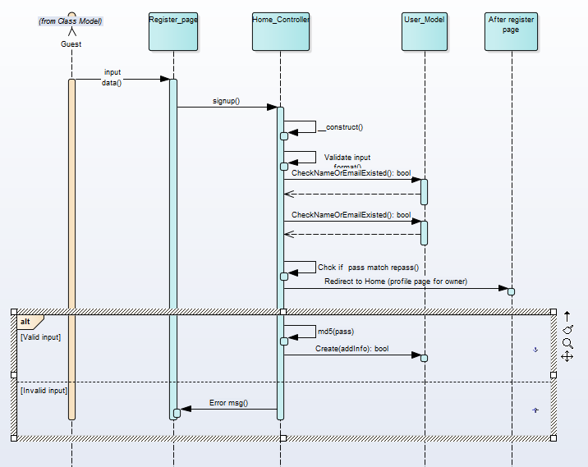

Figure 82: Register diagram

### UC004 – 02 View news by category

#### Screen Design

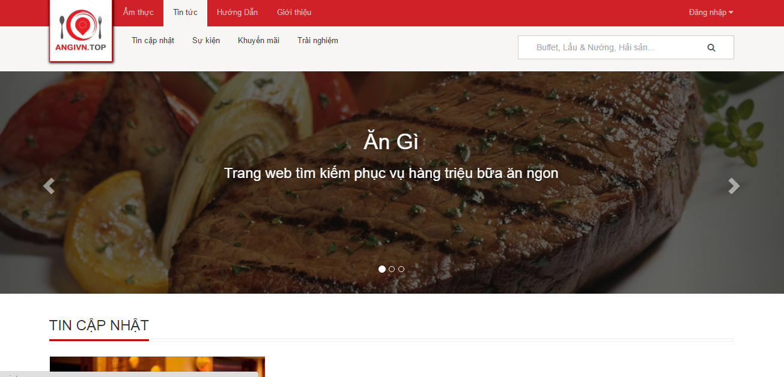

Figure 83: View news by category

|  |  |  |  |  |  |  |
| --- | --- | --- | --- | --- | --- | --- |
| **No** | **Object/ Control Name** | **Object/ Control Name in English** | **Type** | **Required** | **Length** | **Description** |
| 1 | Tin tức | News | Button | Yes | N/A | Click to display categories of news |

Table 40: View news by category

#### Sequence diagram

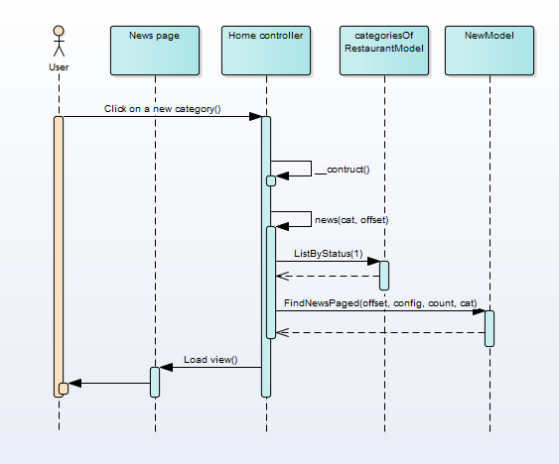

Figure 84: View news by category sequence diagram

### UC004 – 03 View news detail

#### Screen Design

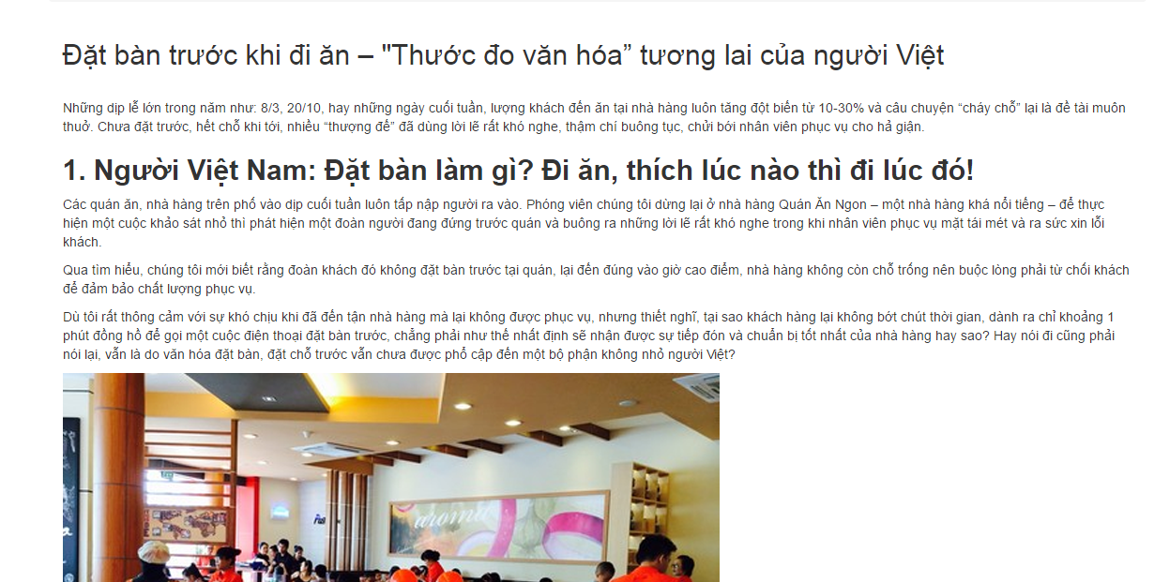

Figure 85: View news detail

#### Sequence diagram

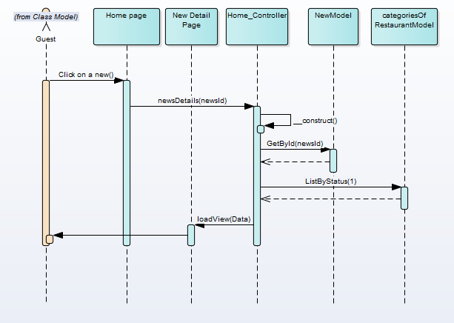

Figure 86: View news detail seqence diagram

### UC004 – 04 Filter restaurant by category

#### Screen Design

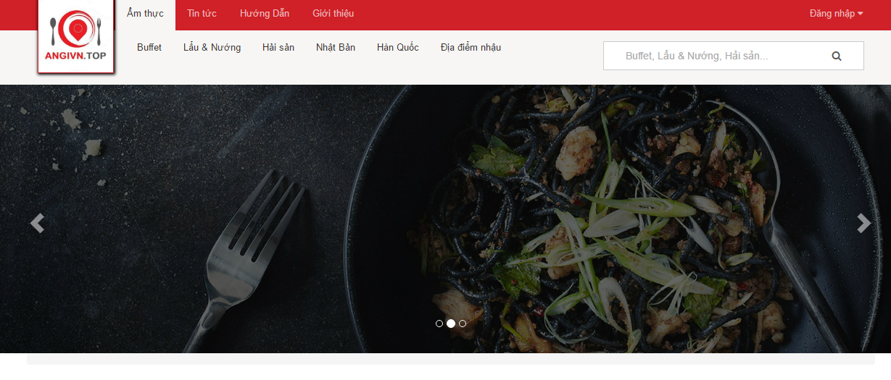

Figure 87: Filter restaurant by category

|  |  |  |  |  |  |  |
| --- | --- | --- | --- | --- | --- | --- |
| **No** | **Object/ Control Name** | **Object/ Control Name in English** | **Type** | **Required** | **Length** | **Description** |
| 1 | Ẩm thực | Cuisine | Button | Yes | N/A | Click to display categories of restaurant |

Table 41: Filter restaurant by category

#### Sequence diagram

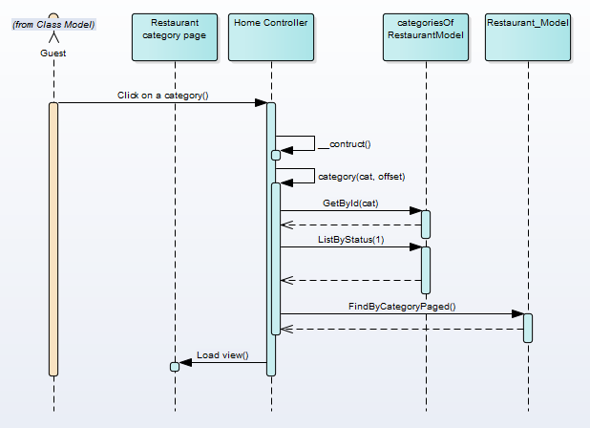

Figure 88: Filter restaurant by category sequence diagram

### UC004 – 05 View restaurant detail

#### Screen Design

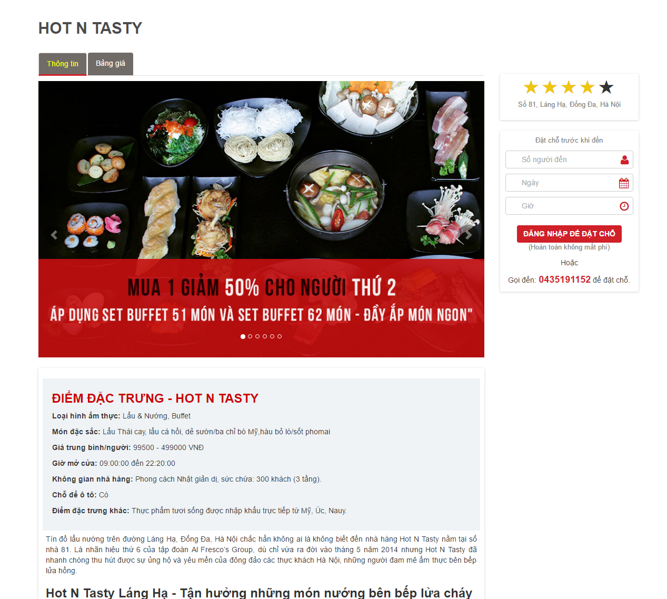

Figure 89: View restaurant detail

#### Sequence diagram

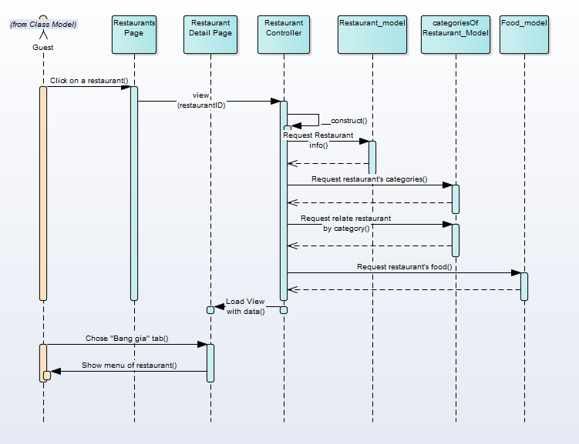

Figure 90: View restaurant detail sequence diagram

### UC004 – 06 Like/Unlike

#### Screen Design

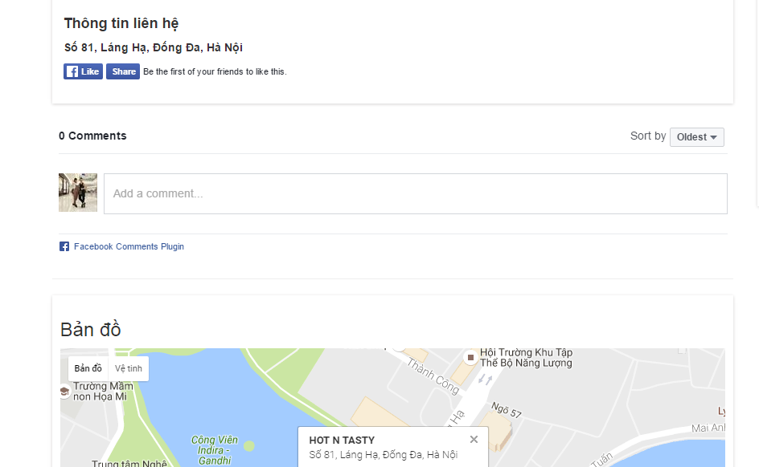

Figure 91: Like/unlike by Facebook

|  |  |  |  |  |  |  |
| --- | --- | --- | --- | --- | --- | --- |
| **No** | **Object/ Control Name** | **Object/ Control Name in English** | **Type** | **Required** | **Length** | **Description** |
| 1 | Like | Like | Button | Yes | N/A | Click to like/unlike restaurant |

Table 42: Like/unlike by Facebook

#### Sequence diagram

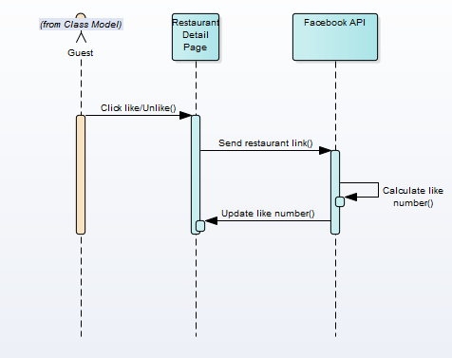

Figure 92: Like/unlike sequence diagram

### UC004 – 07 Comment

#### Screen Design



Figure 93: Comment by Facebook

|  |  |  |  |  |  |  |
| --- | --- | --- | --- | --- | --- | --- |
| **No** | **Object/ Control Name** | **Object/ Control Name in English** | **Type** | **Required** | **Length** | **Description** |
| 1 | Add a comment | Add a comment | Textbox | Yes | N/A | Input comment of guest |

Table 43: Comment by Facebook

#### Sequence diagram

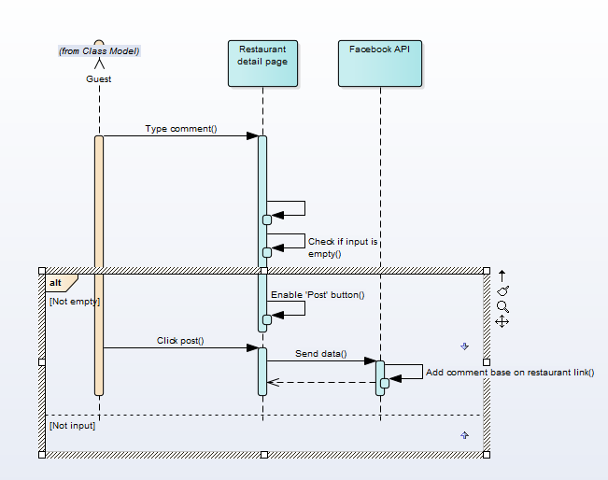

Figure 94: Comment sequence diagram

### UC004 – 08 Share

#### Screen Design



Figure 95: Social network share

|  |  |  |  |  |  |  |
| --- | --- | --- | --- | --- | --- | --- |
| **No** | **Object/ Control Name** | **Object/ Control Name in English** | **Type** | **Required** | **Length** | **Description** |
| 1 | Share | Share | Button | Yes | N/A | Click to share restaurant |

Table 44: Social network share

#### Sequence diagram

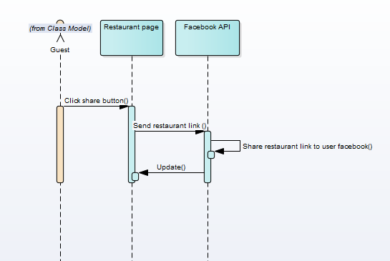

Figure 96: Social network share sequence diagram

# DATABASE DESIGN

## Database Diagram

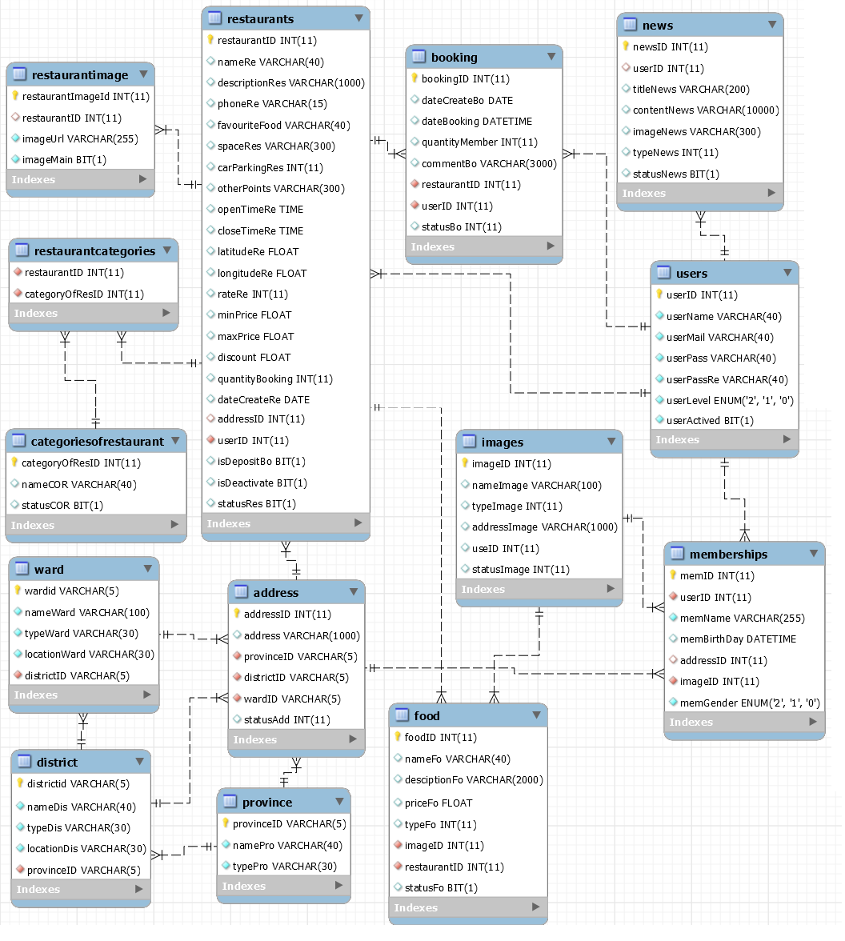

Figure 97: AGC database diagram

## Table Descriptions

### Table address

|  |  |  |  |  |  |  |
| --- | --- | --- | --- | --- | --- | --- |
| No | Attribute | Type | Size | Null able | Constraints | Description |
| 1 | addressID | int |  | no | primary key | unique value identifies address, auto increment |
| 2 | address | nvarchar | 100 | no |  | specific address |
| 3 | provinceID | nvarchar | 5 | no | foreign key constraint, referral table province | unique value identifies province |
| 4 | districtID | nvarchar | 5 | no | foreign key constraint, referral table district | unique value identifies district |
| 5 | wardID | nvarchar | 5 | no | foreign key constraint, referral table ward | unique value identifies ward |

Table 45: Address table

### Table booking

|  |  |  |  |  |  |  |
| --- | --- | --- | --- | --- | --- | --- |
| No | Attribute | Type | Size | Null able | Constraints | Description |
| 1 | bookingID | int |  | no | primary key | unique value identifies booking, auto increment |
| 2 | dateCreateBo | date |  | yes |  | the date that customers make reservation |
| 3 | dateBooking | dateTime |  | no |  | date and time that customers will visit restaurant |
| 4 | quantityMember | int |  | no |  | number of people |
| 5 | commentBo | nvarchar | 300 | yes |  | other feedback or request |
| 6 | restaurantID | int |  | no | foreign key constraint, referral table restaurants | unique value identifies restaurant |
| 7 | userID | int |  | no | foreign key constraint, referral table users | unique value identifies user |

Table 46: Booking table

### Table categoriesofrestaurant

|  |  |  |  |  |  |  |
| --- | --- | --- | --- | --- | --- | --- |
| No. | Attribute | Type | Size | Null able | Constraints | Description |
| 1 | categoryOfResID | int |  | no | primary key | unique value identifies restaurant category, auto increment |
| 2 | nameCOR | nvarchar | 300 | no |  | restaurant category name |

Table 47: CategoriesofRestaurant

### Table district

|  |  |  |  |  |  |  |
| --- | --- | --- | --- | --- | --- | --- |
| No | Attribute | Type | Size | Null able | Constraints | Description |
| 1 | districtID | nvarchar | 5 | no | primary key | unique value identifies district |
| 2 | nameDis | nvarchar | 100 | no |  | district name |
| 3 | typeDis | nvarchar | 30 | no |  | type of districts in Vietnam |
| 4 | locationDis | nvarchar | 30 | yes |  | latitude and longitude of the district |

Table 48: Distric table

### Table food

|  |  |  |  |  |  |  |
| --- | --- | --- | --- | --- | --- | --- |
| No | Attribute | Type | Size | Null able | Constraints | Description |
| 1 | foodID | int |  | no | primary key | unique value identifies food, auto increment |
| 2 | nameFo | nvarchar | 30 | no |  | food name |
| 3 | descriptionFo | nvarchar | 2000 | yes |  | description of food |
| 4 | priceFo | float |  | yes |  | food price |
| 5 | typeFo | int |  | yes |  | type of food 0 to be “tráng miêng”, 1 to be “ăn nhanh” 2 to be “bữa chính” |
| 6 | imageID | int |  | no | foreign key constraint, referral table images | unique value identifies food’s image, |
| 7 | restaurantID | int |  | no | foreign key constraint, referral table restaurants | unique value identifies restaurant |

Table 49: Food table

### Table images

|  |  |  |  |  |  |  |
| --- | --- | --- | --- | --- | --- | --- |
| No | Attribute | Type | Size | Null able | Constraints | Description |
| 1 | imageID | int |  | no | primary key | unique value identifies image, auto increment |
| 2 | nameImage | nvarchar | 100 | no |  | image name |
| 3 | typeImage | int |  | no |  | type of image |
| 4 | addressImage | nvarchar | 200 | no |  | url or path to images’ files |

Table 50: Image table

### Table memberships

|  |  |  |  |  |  |  |
| --- | --- | --- | --- | --- | --- | --- |
| No | Attribute | Type | Size | Null able | Constraints | Description |
| 1 | memID | int |  | no | primary key | unique value identifies membership, auto increment |
| 2 | userID | int |  | no | foreign key constraint, referral table users | unique value identifies user |
| 3 | memName | nvarchar | 40 | no |  | membership name |
| 4 | addressID | int |  | no | foreign key constraint, referral table address | unique value identifies address |
| 5 | imageID | int |  | no | foreign key constraint, referral table images | unique value identifies image |
| 6 | memGender | enum(‘2’, ‘1’, ‘0’) |  | no |  | gender 2 to be male 1 to be female and 0 to be other |

Table 51: Membership table

### Table news

|  |  |  |  |  |  |  |
| --- | --- | --- | --- | --- | --- | --- |
| No | Attribute | Type | Size | Null able | Constraints | Description |
| 1 | newsID | int |  | no | primary key | unique value identifies news, auto increment |
| 2 | userID | int |  | no | foreign key constraint, referral table users | unique value identifies user |
| 3 | titleNews | nvarchar | 100 | no |  | news title |
| 4 | contentNews | nvarchar | 10000 | no |  | content of news |
| 5 | imageNews | nvarchar |  | yes |  | images used in news content |
| 6 | typeNews | int |  | yes |  | type of news 0 is “tin cập nhật” 1 is “sự kiện” 2 is “khuyền mãi” 3 is “trải nhiệm” |

Table 52: News table

### Table province

|  |  |  |  |  |  |  |
| --- | --- | --- | --- | --- | --- | --- |
| No. | Attribute | Type | Size | Null able | Constraints | Description |
| 1 | provinceID | nvarchar | 5 | no | primary key | unique value identifies province, auto increment |
| 2 | namePro | nvarchar | 40 | no |  | province name |
| 3 | typePro | nvarchar | 30 | no |  | province type |

Table 53: Province table

### Table restaurantcategories

|  |  |  |  |  |  |  |
| --- | --- | --- | --- | --- | --- | --- |
| No | Attribute | Type | Size | Null able | Constraints | Description |
| 1 | restaurantID | int |  | no | foreign key constraint, ,referral table restaurants | unique value identifies restaurant |
| 2 | categoryOfResID | int |  | no | foreign key constraint, referral table categoriesofrestaurant | unique value identifies restaurant category |

Table 54: Restaurantcategory table

### Table restaurantImage

|  |  |  |  |  |  |  |
| --- | --- | --- | --- | --- | --- | --- |
| No | Attribute | Type | Size | Null able | Constraints | Description |
| 1 | restaurantImageID | int |  | no | primary key | unique value identifies restaurant image, auto increment |
| 2 | restaurantID | int |  | no | foreign key constraint, referral table restaurants | unique value identifies restaurant |
| 3 | imageUrl | nvarchar | 200 | no |  | url or path to the images’ files |
| 4 | imageMain | bit |  | yes |  | is the image is as restaurant profile 1 is used 0 is not |

Table 55: RestaurantImage table

### Table restaurants

|  |  |  |  |  |  |  |
| --- | --- | --- | --- | --- | --- | --- |
| No. | Attribute | Type | Size | Null able | Constraints | Description |
| 1 | restaurantID | int |  | no | primary key | unique value identifies restaurant, auto increment |
| 2 | nameRe | nvarchar | 40 | no |  | name of the restaurant |
| 3 | descriptionRes | nvarchar | 1000 | yes |  | restaurant description |
| 4 | phoneRe | nvarchar | 15 | no |  | phone number |
| 5 | favouriteFood | nvarchar | 40 | yes |  | special of famous dishes |
| 6 | spaceRes | nvarchar | 300 | yes |  | how big the restaurant is |
| 7 | carparkingRes | int |  | yes |  | is there a car parking 0 is yes 1 is no |
| 8 | openTimeRe | time |  | yes |  | restaurant opening time |
| 9 | closeTimeRe | time |  | yes |  | restaurant closing time |
| 10 | latitudeRe | float |  | yes |  | latitude of the restaurant |
| 11 | longitudeRe | float |  | yes |  | longitude of the restaurant |
| 12 | rateRe | int |  | no |  | restaurant rating |
| 13 | minPrice | float |  | yes |  | minimum price per meal |
| 14 | maxPrice | float |  | yes |  | max price per meal |
| 15 | discount | float |  | yes |  | restaurant discount for customer |
| 16 | quantityBooking | int |  | no |  | number of booking times |
| 17 | dateCreateRe | date |  | no |  | date restaurant register on the system |
| 18 | addressID | int |  | no | foreign key constraint, referral table address | unique value identifies address |
| 19 | userID | int |  | no | foreign key constraint, referral table users | unique value identifies user |
| 20 | statusRes | bit |  | no |  | is restaurant is active or not 0 is active 1 is inactive |

Table 56: Restaurants table

### Table users

|  |  |  |  |  |  |  |
| --- | --- | --- | --- | --- | --- | --- |
| No. | Attribute | Type | Size | Null able | Constraints | Description |
| 1 | userID | int |  | no | primary key | unique value identifies user |
| 2 | userName | nvarchar | 40 | no |  | unique user name |
| 3 | userMail | nvarchar | 40 | no |  | user email |
| 4 | userPass | nvarchar | 40 | no |  | user password |
| 5 | userPassRe | nvarchar | 40 | no |  | user confirm password |
| 6 | userLevel | enum(‘2’,’1’,’0’) |  | no |  | level of user 2 is admin 1 is restaurant owner 0 is customer |
| 7 | userActived | bit |  | no |  | is user is active or not 0 is yes 1 is not |

Table 57: User table

### Table ward

|  |  |  |  |  |  |  |
| --- | --- | --- | --- | --- | --- | --- |
| No | Attribute | Type | Size | Null able | Constraints | Description |
| 1 | wardID | nvarchar | 5 | no | primary key | unique value identifies district |
| 2 | nameWard | nvarchar | 40 | no |  | village name |
| 3 | typeWard | nvarchar | 40 | yes |  | type of villages in Vietnam |
| 4 | locationWard | nvarchar | 40 | no |  | latitude and longitude |
| 5 | districtID | nvarchar | 5 | no | foreign key constraint, referral table district | unique value identifies district |

Table 58: Ward table

# References

<http://www.codeigniter.com/>